Automotive Digital Cockpit - Design Document

Author: Abhishek Chauhan

List of Figures

Figure 1: @startuml title Socket.IO_ emit() with reserved event check, sockets.emit(_message_), and serverSideEmit() actor Developer as Dev participant _Socket_n(Client or Server)_ as Sock participant _Server A_ as SA participant _.png

Figure 2: Cluster Communication Flow (Copy).png

Figure 3: Cluster Communication Flow.png

Figure 4: Frontend WS ping_pong + Backend Socket.IO serverSideEmit(_ping_) with ACKs(1).png

Figure 5: Frontend WS ping_pong + Backend Socket.IO serverSideEmit(_ping_) with ACKs(2).png

Figure 6: Frontend WS ping_pong + Backend Socket.IO serverSideEmit(_ping_) with ACKs.png

Figure 7: Frontend WebSocket ping_pong + Backend Socket.IO serverSideEmit(_ping_).png

Figure 8: Socket.IO Event Flow_ emit(), sockets.emit(_message_), and serverSideEmit().png

Figure 9: Socket.IO Event Flow_ emit(), write(_message_), and serverSideEmit().drawio.png

Figure 10: Socket.IO Flow_ emit() with _registerAckCallback, write(), and serverSideEmit().png

Figure 11: Socket.IO Flow_ emit(), sockets.emit(_message_), serverSideEmit().png

Figure 12: Socket.IO Flow_ emit(), write(_message_), and serverSideEmit().png

Figure 13: Socket.IO Sequence_ emit(), sockets.emit(_message_), serverSideEmit().png

Figure 14: Socket.IO client emit, server broadcast, and server-side emit.png

Figure 15: Socket.IO event flow with RESERVED_EVENTS check, write(_message_), and serverSideEmit.drawio.png

Figure 16: Socket.IO flow_ client emit(), server sockets.emit(_message_), and io.serverSideEmit(...).drawio.png

Figure 17: Socket.IO flow_ emit() override (safe), write(_message_) broadcast, serverSideEmit() with ACKs.png

Figure 18: Socket.IO flow_ emit() override, write(_message_), serverSideEmit().png

Figure 19: Socket.IO flow_ emit(), write(_message_), and serverSideEmit().png

Figure 20: Socket.IO flow_ emit_Ev_(), _registerAckCallback, write(_message_), serverSideEmit(.png

Figure 21: Socket.IO flow_ safe emit(), namespace write(_message_), serverSideEmit() with ACKs(1).png

Figure 22: Socket.IO flow_ safe emit(), namespace write(_message_), serverSideEmit() with ACKs.png

Figure 23: Socket.IO flow_ send(), emit(), write(_message_), and serverSideEmit().png

Figure 24: Socket.IO flow_ socket.send_emit(), io.write(_message_), and io.serverSideEmit(...).png

Figure 25: Socket.IO lifecycle_ emit(), namespace broadcast, serverSideEmit().png

Figure 26: Socket.IO send()_emit(), write(_message_), and serverSideEmit().png

Figure 27: Socket.IO sequence_ emit(), write(_message_), serverSideEmit().png

Figure 28: Socket.IO sequence_ send(), emit(), write(_message_), and serverSideEmit().png

Figure 29: Socket.IO_ client emit(), server write(_message_), and io.serverSideEmit().png

Figure 30: Socket.IO_ emit() + _registerAckCallback + write(_message_) + serverSideEmit().png

Figure 31: Socket.IO_ emit() override + namespace _message_ broadcast + serverSideEmit() with ACKs.png

Figure 32: Socket.IO_ emit() override + namespace _message_ broadcast + serverSideEmit().png

Figure 33: Socket.IO_ emit() override + namespace write(_message_) + serverSideEmit() with ACKs.png

Figure 34: Socket.IO_ emit() override + write(_message_) + serverSideEmit() with ACKs(1).png

Figure 35: Socket.IO_ emit() override + write(_message_) + serverSideEmit() with ACKs(2).png

Figure 36: Socket.IO_ emit() override + write(_message_) + serverSideEmit() with ACKs(3).png

Figure 37: Socket.IO_ emit() override + write(_message_) + serverSideEmit() with ACKs(4) (Copy).png

Figure 38: Socket.IO_ emit() override + write(_message_) + serverSideEmit() with ACKs(4).png

Figure 39: Socket.IO_ emit() override + write(_message_) + serverSideEmit() with ACKs..png

Figure 40: Socket.IO_ emit() override + write(_message_) + serverSideEmit() with ACKs.png

Figure 41: Socket.IO_ emit() override + write(_message_) + serverSideEmit()(1).png

Figure 42: Socket.IO_ emit() override + write(_message_) + serverSideEmit()(2).png

Figure 43: Socket.IO_ emit() override + write(_message_) + serverSideEmit()(3).png

Figure 44: Socket.IO_ emit() override + write(_message_) + serverSideEmit().png

Figure 45: Socket.IO_ emit() override, namespace write(_message_), cluster serverSideEmit().png

Figure 46: Socket.IO_ emit() override, namespace write(_message_), serverSideEmit().png

Figure 47: Socket.IO_ emit() override, write(_message_), serverSideEmit() with ACKs.png

Figure 48: Socket.IO_ emit() override, write(_message_), serverSideEmit().png

Figure 49: Socket.IO_ emit() with _registerAckCallback, write(_message_), serverSideEmit().png

Figure 50: Socket.IO_ emit(), write(_message_), serverSideEmit().png

Figure 51: Socket.IO_ send(), emit() override, write(_message_), serverSideEmit().png

Figure 52: Socket.IO_ send(), emit(), write(_message_), and serverSideEmit().png

Figure 53: Socket.IO_ send(), emit(), write(_message_), serverSideEmit().png

Figure 54: Socket.IO_ send()_write() via s.unshift + emit(), and serverSideEmit().png

Figure 55: Untitled DiSocket.IO_ send(), emit() override, write(_message_), serverSideEmit()agram.png

Figure 56: WebSocket ping_pong (frontend) vs Socket.IO serverSideEmit(_ping_) (backend).png

Figure 57: socket.IO Flow_ emit() with _registerAckCallback, sockets.emit(_message_), and serverSideEmit().png

Figure 58: socket.IO Flow_ emit() with reserved event check, write(_message_), and serverSideEmit().png

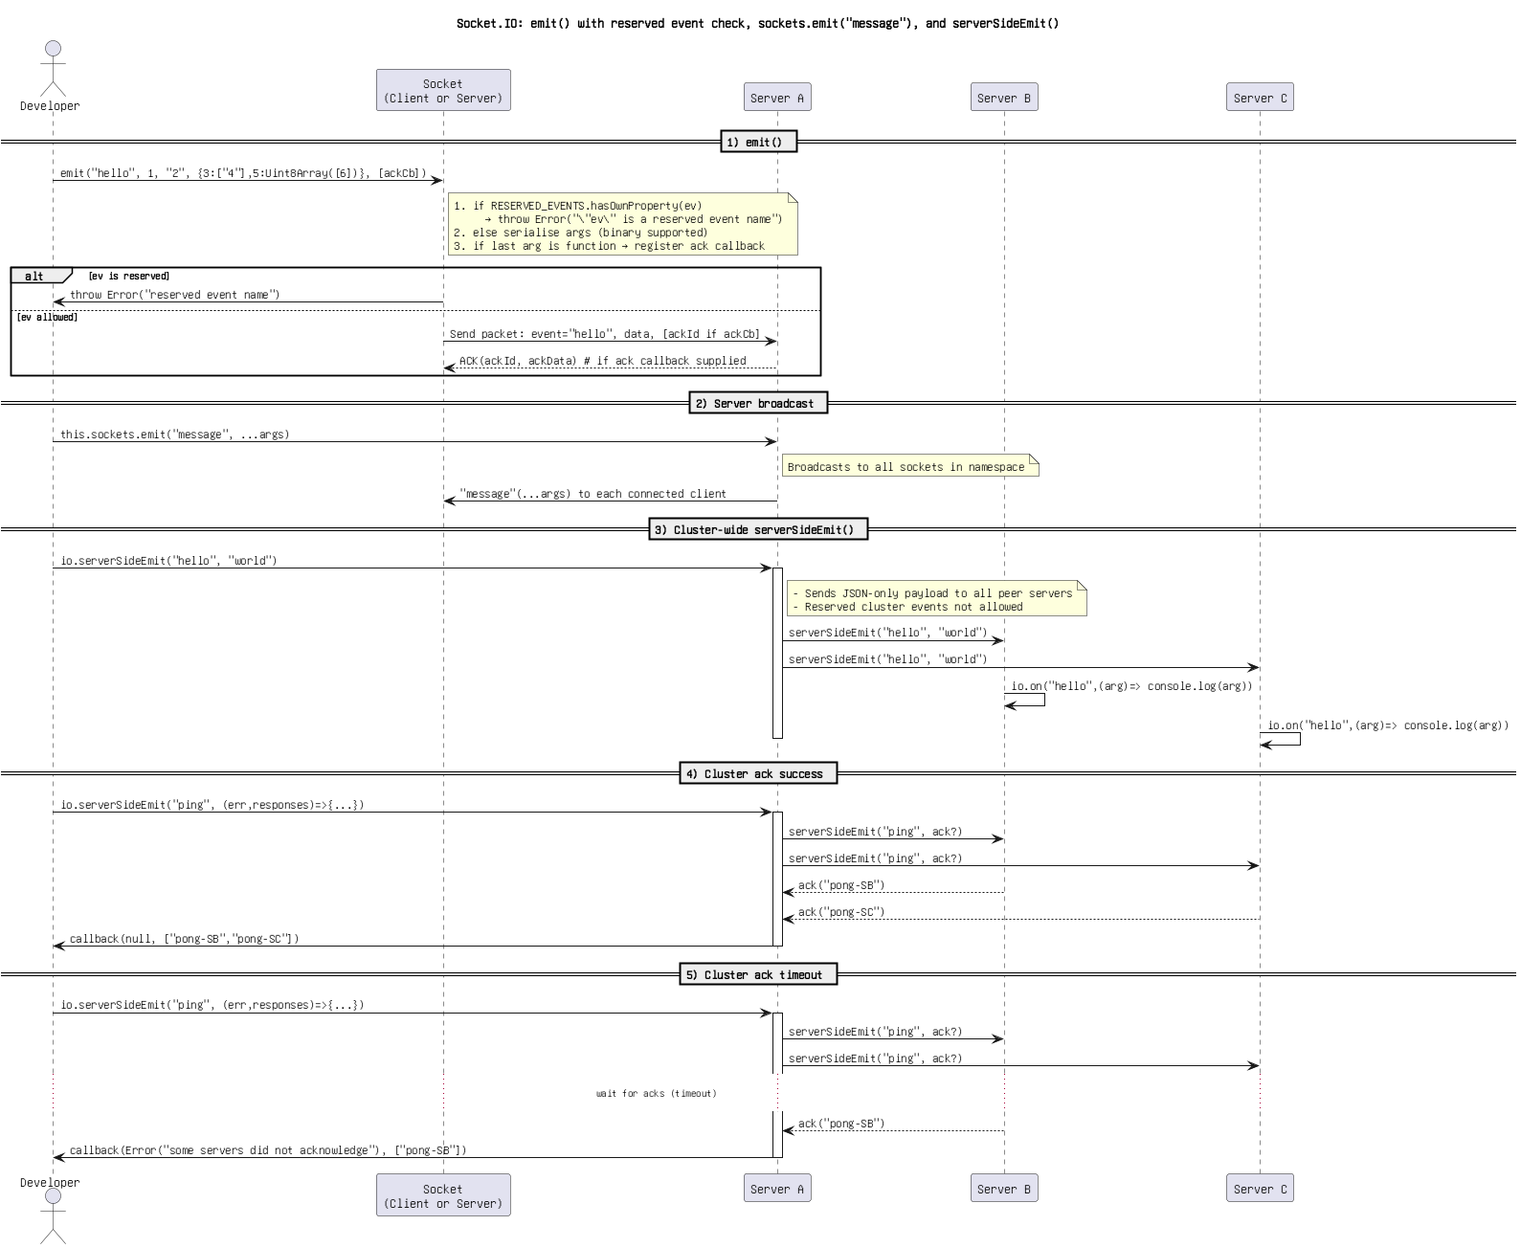

Figure 1: @startuml title Socket.IO_ emit() with reserved event check, sockets.emit(_message_), and serverSideEmit() actor Developer as Dev participant _Socket_n(Client or Server)_ as Sock participant _Server A_ as SA participant _.png

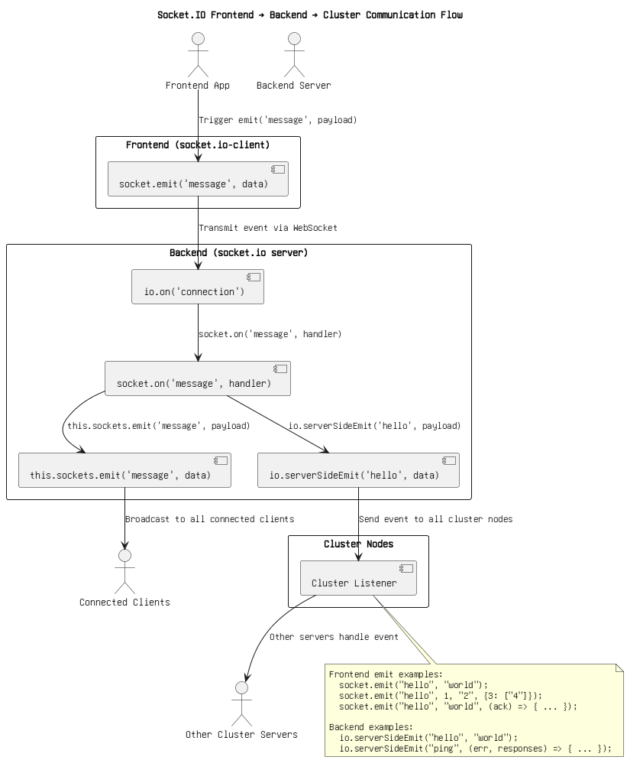

Figure 2: Cluster Communication Flow (Copy).png



Figure 3: Cluster Communication Flow.png

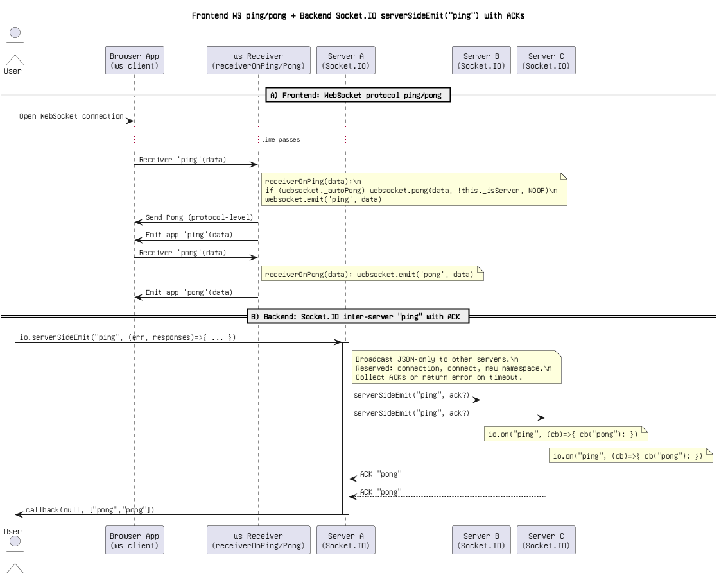

Figure 4: Frontend WS ping_pong + Backend Socket.IO serverSideEmit(_ping_) with ACKs(1).png

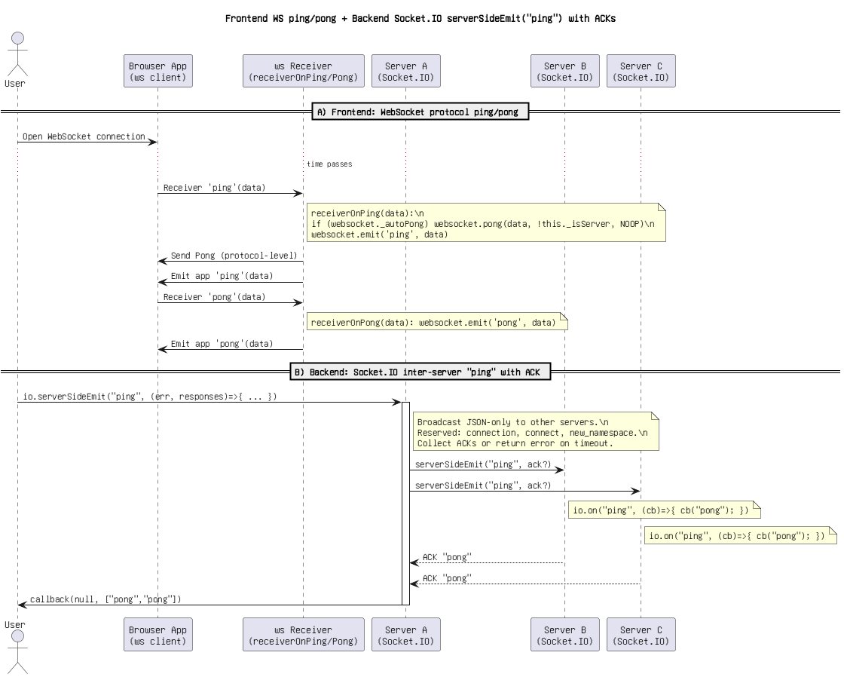

Figure 5: Frontend WS ping_pong + Backend Socket.IO serverSideEmit(_ping_) with ACKs(2).png

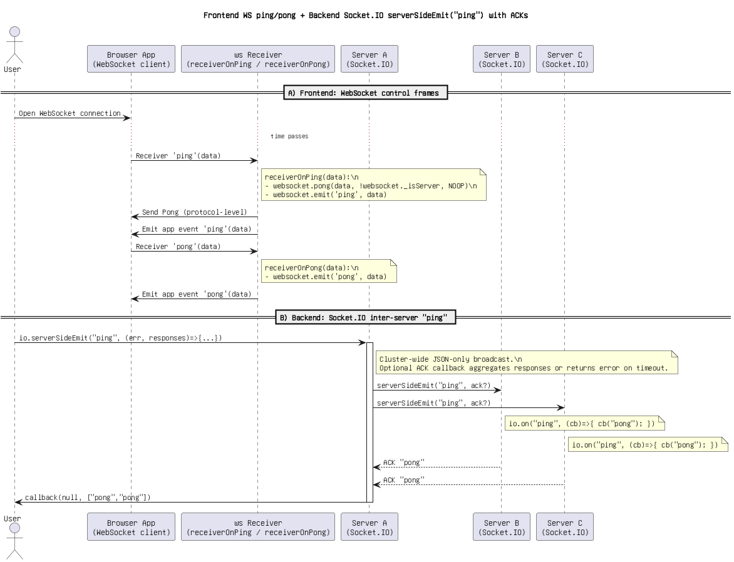

Figure 6: Frontend WS ping_pong + Backend Socket.IO serverSideEmit(_ping_) with ACKs.png

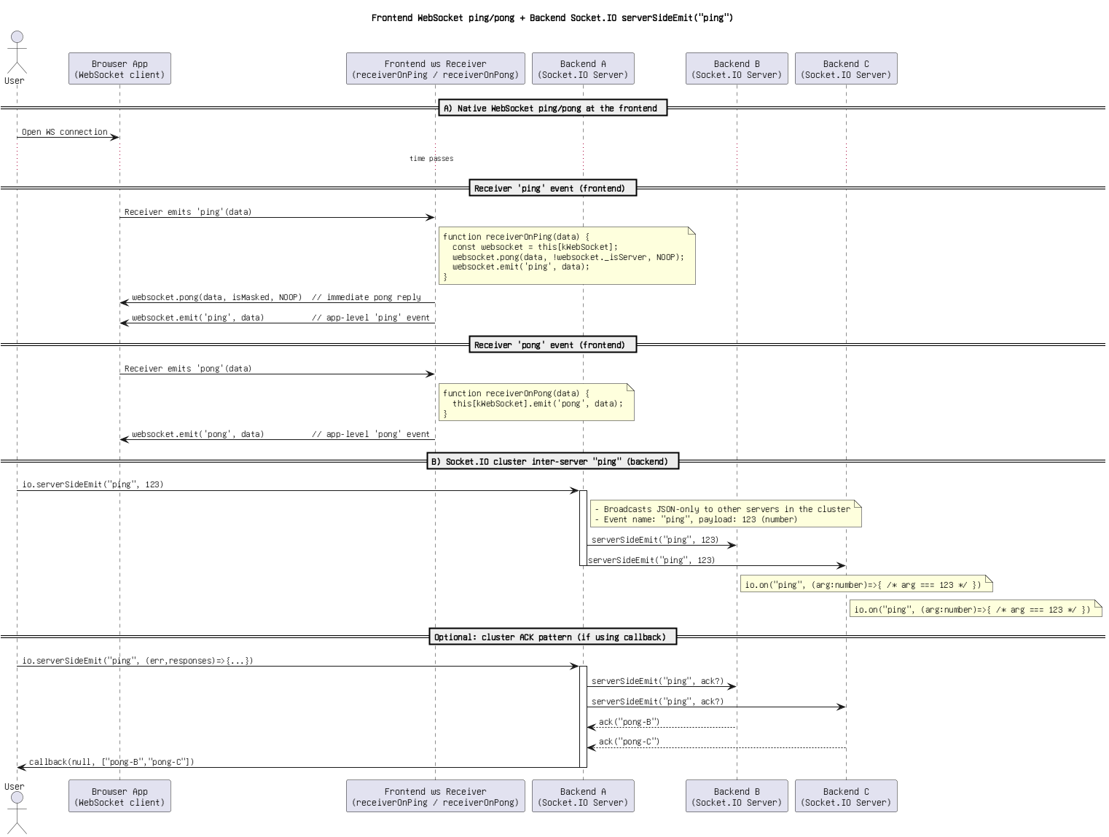

Figure 7: Frontend WebSocket ping_pong + Backend Socket.IO serverSideEmit(_ping_).png

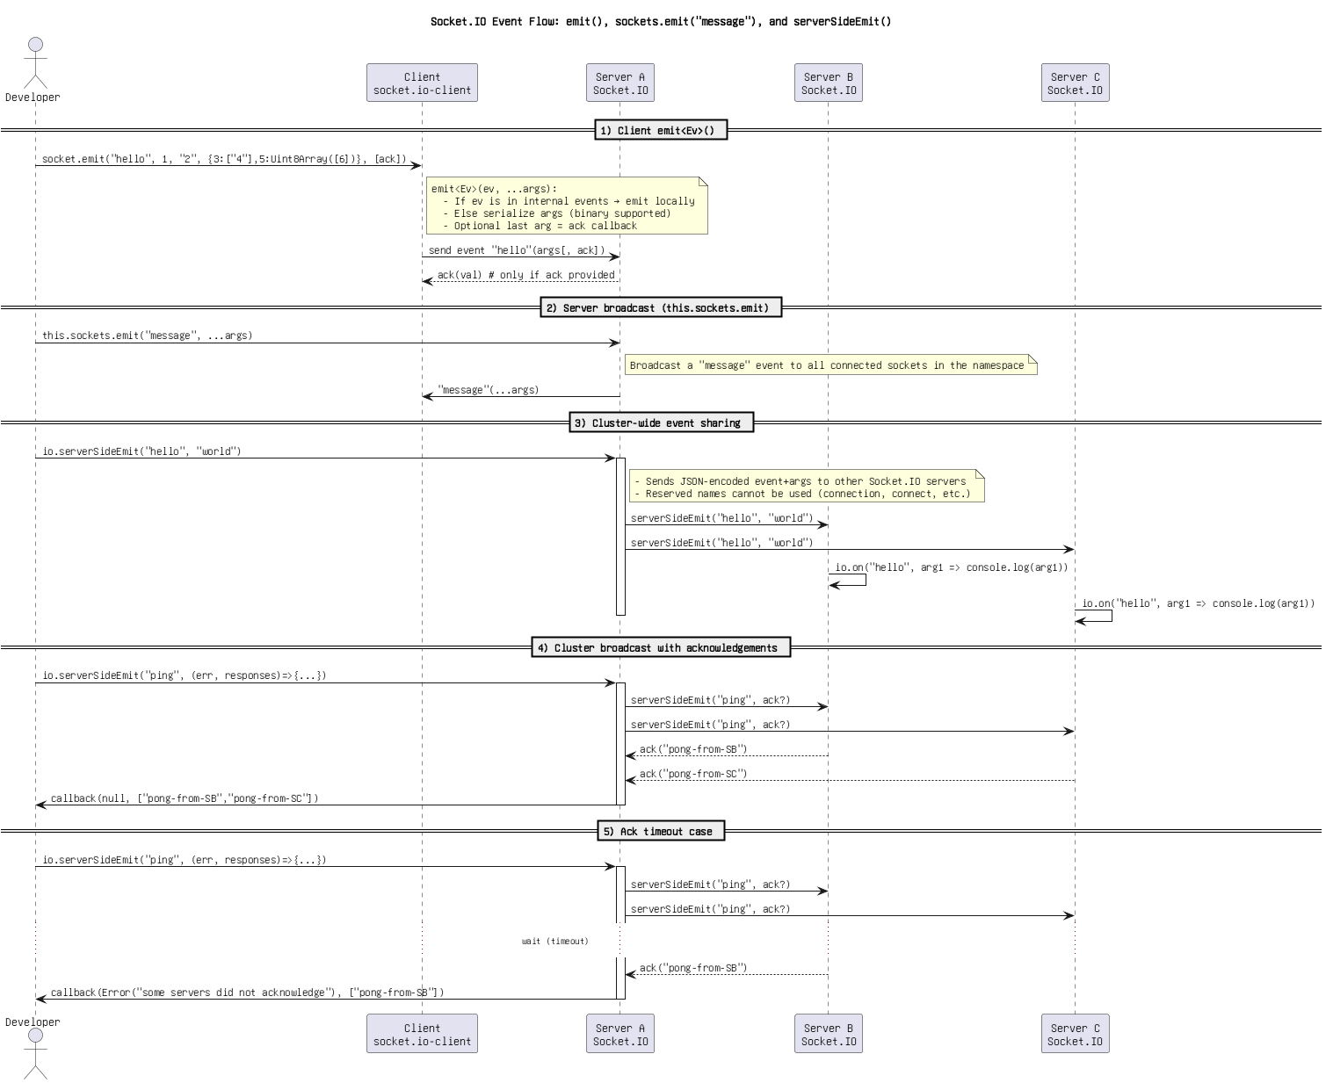

Figure 8: Socket.IO Event Flow_ emit(), sockets.emit(_message_), and serverSideEmit().png

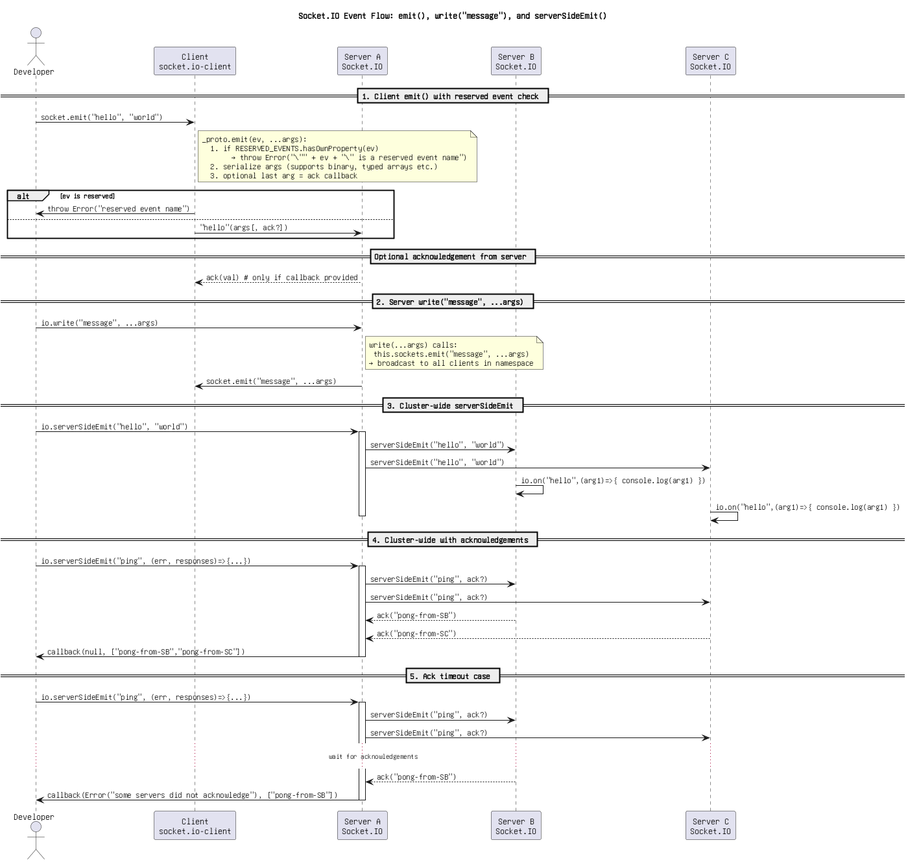

Figure 9: Socket.IO Event Flow_ emit(), write(_message_), and serverSideEmit().drawio.png

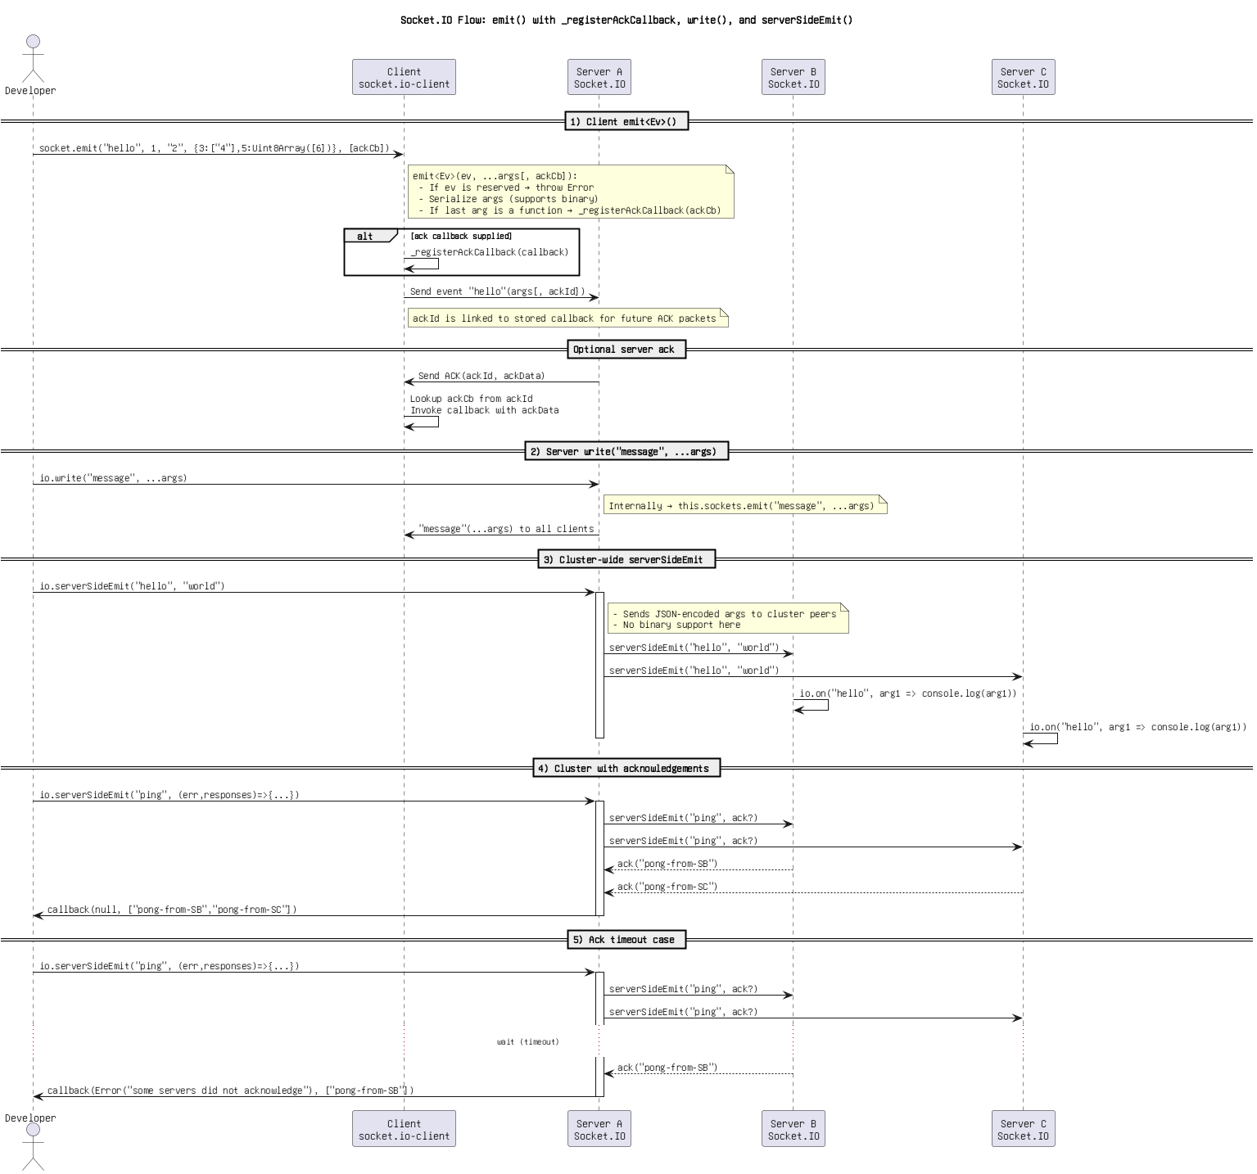

Figure 10: Socket.IO Flow_ emit() with _registerAckCallback, write(), and serverSideEmit().png

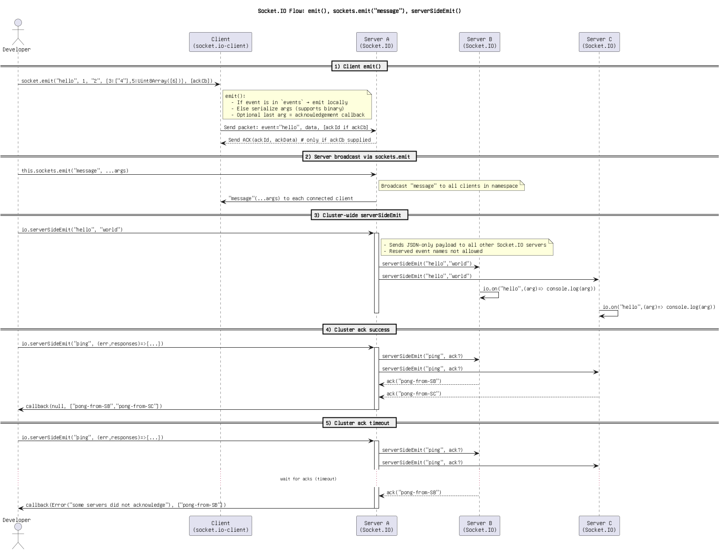

Figure 11: Socket.IO Flow_ emit(), sockets.emit(_message_), serverSideEmit().png

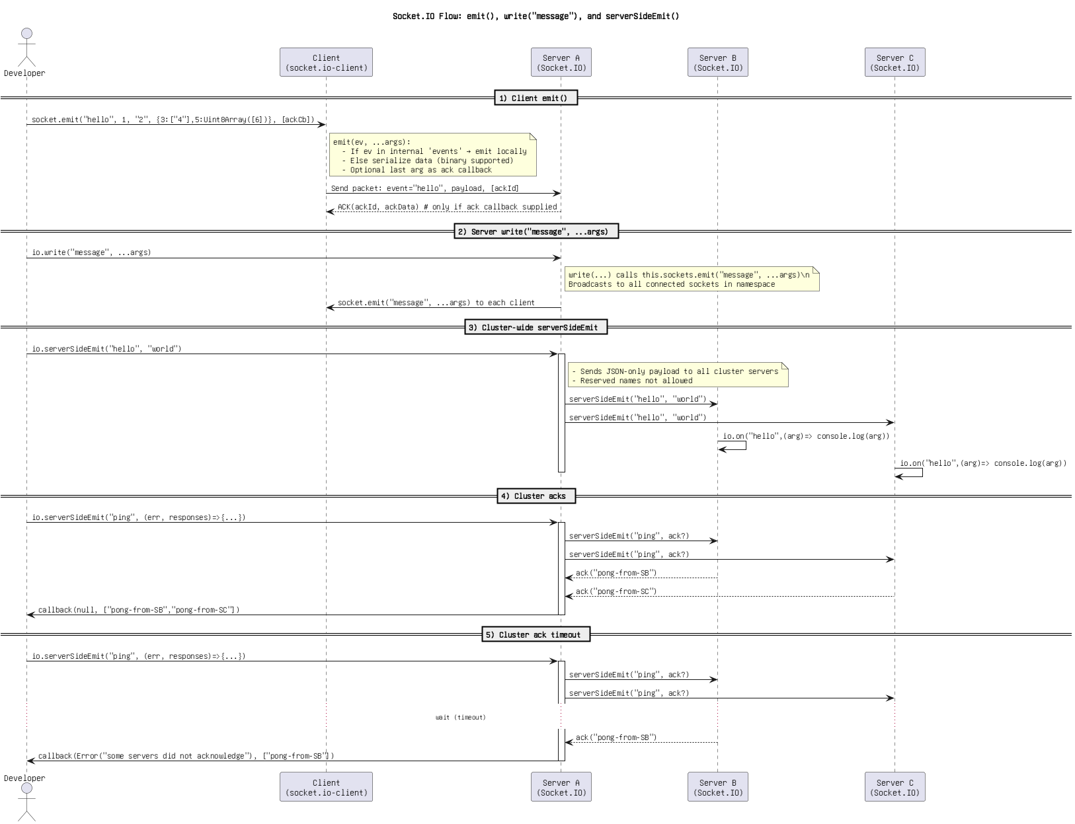

Figure 12: Socket.IO Flow_ emit(), write(_message_), and serverSideEmit().png

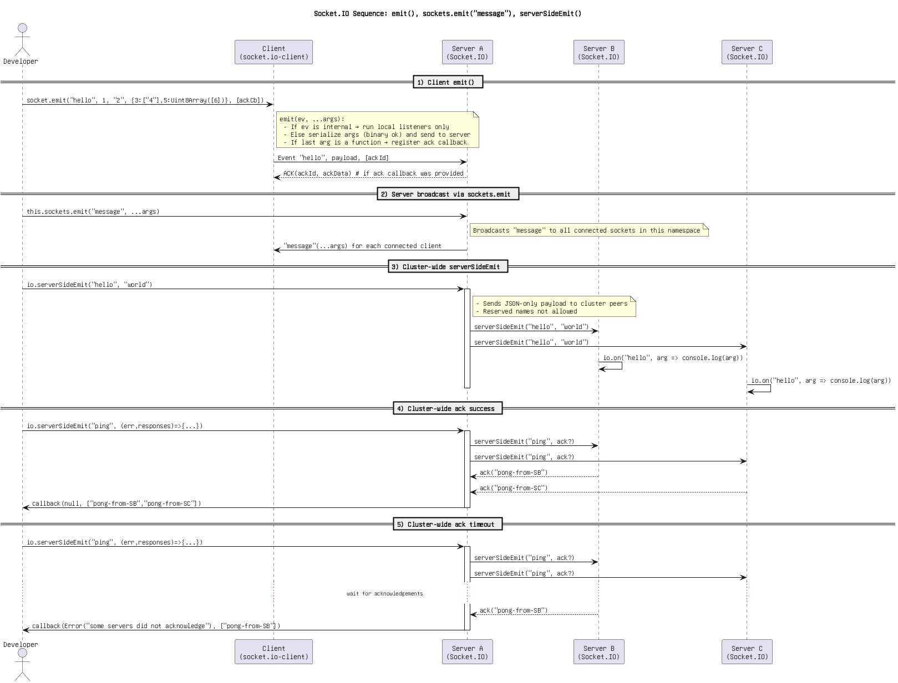

Figure 13: Socket.IO Sequence_ emit(), sockets.emit(_message_), serverSideEmit().png

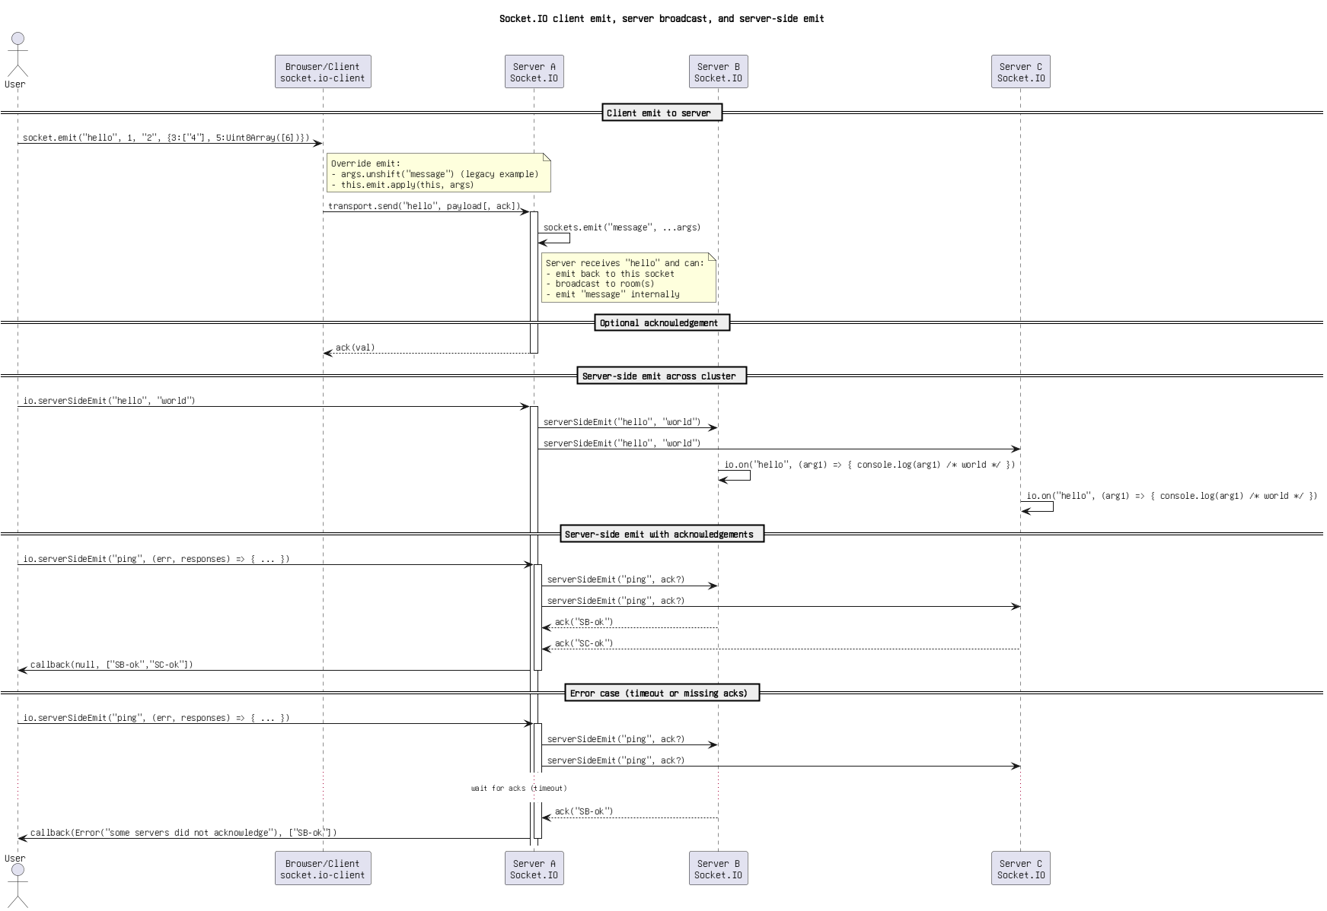

Figure 14: Socket.IO client emit, server broadcast, and server-side emit.png

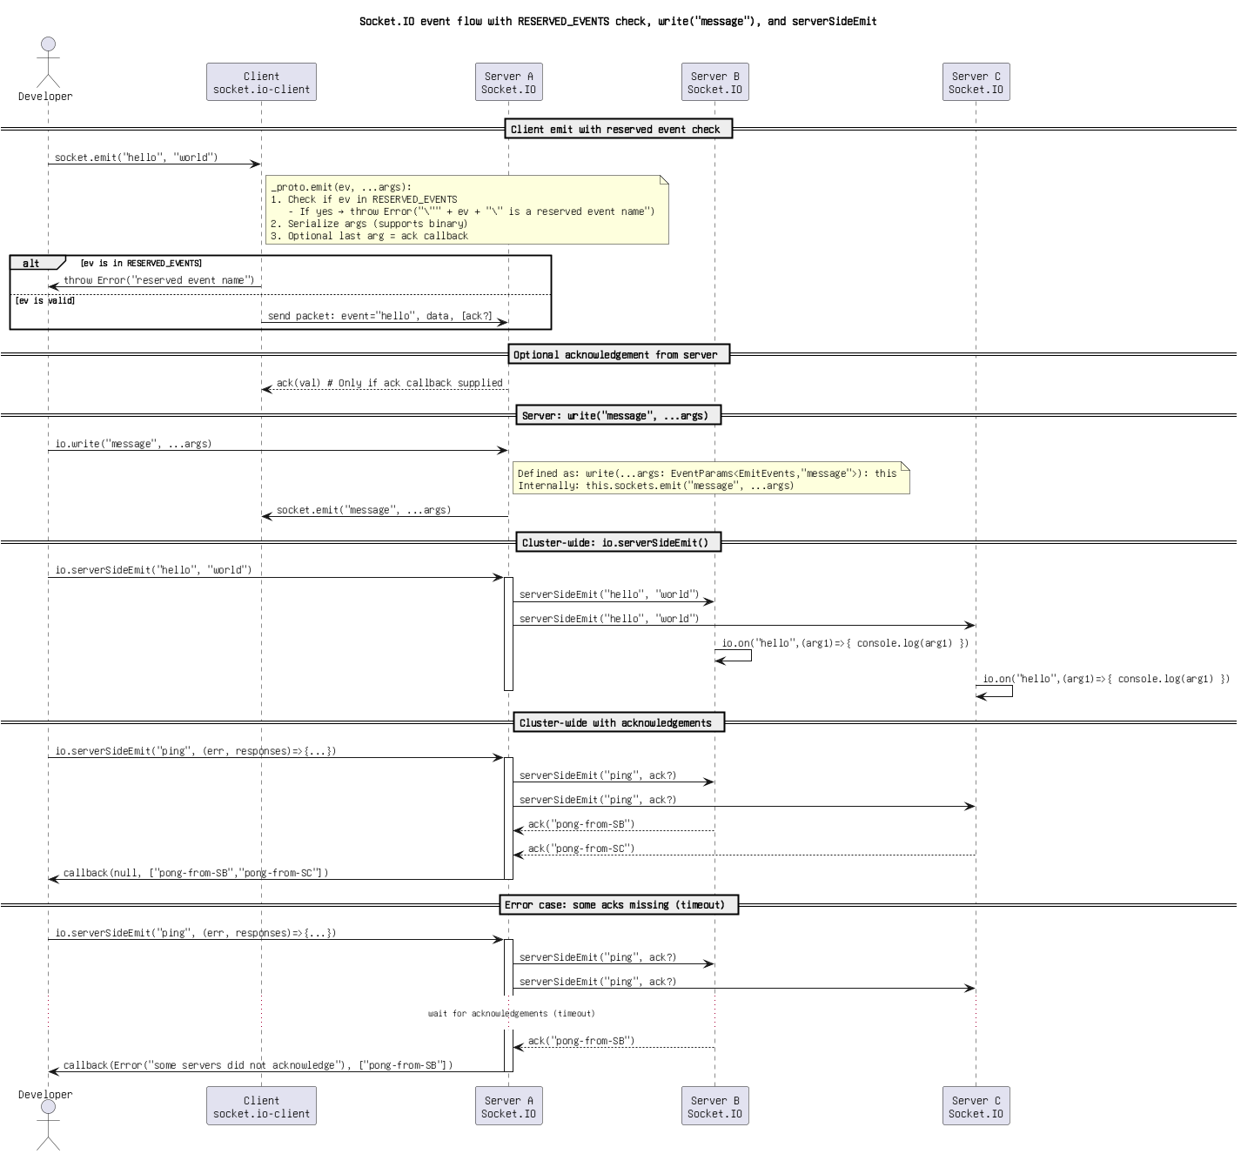

Figure 15: Socket.IO event flow with RESERVED_EVENTS check, write(_message_), and serverSideEmit.drawio.png

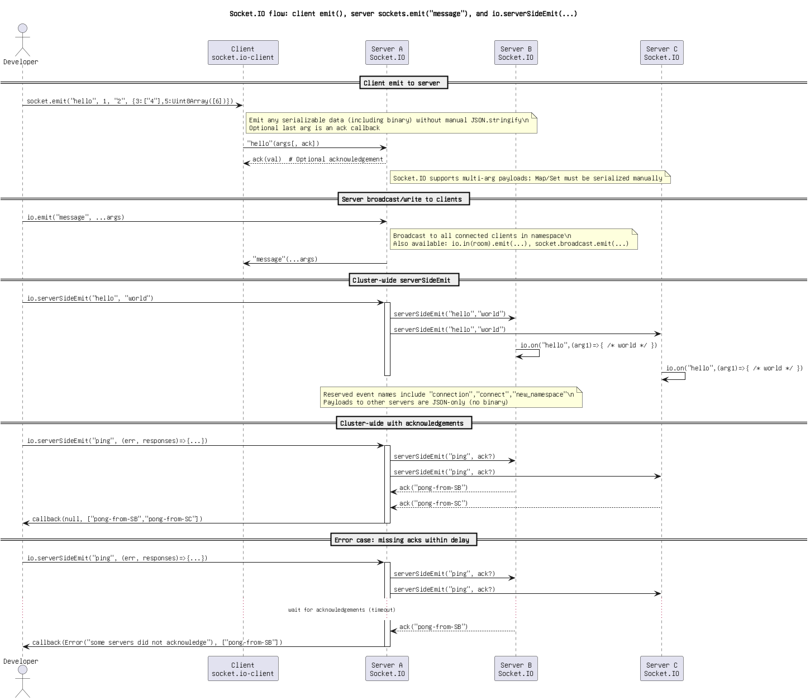

Figure 16: Socket.IO flow_ client emit(), server sockets.emit(_message_), and io.serverSideEmit(...).drawio.png

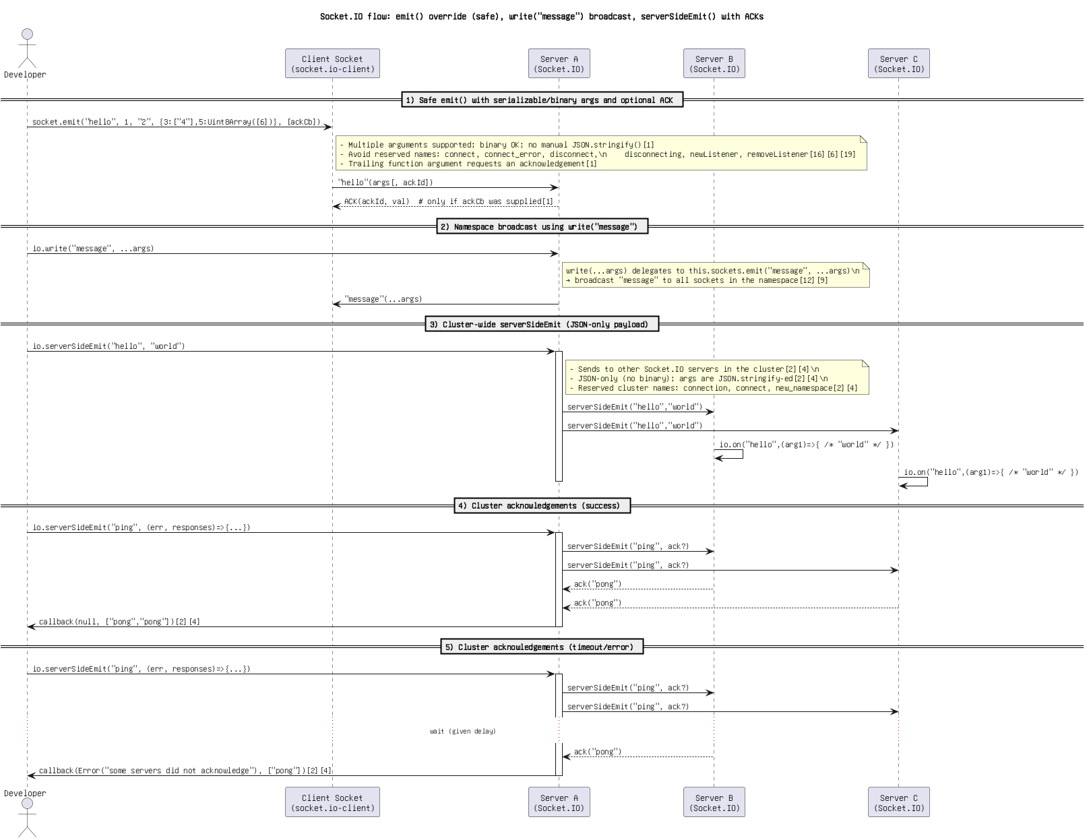

Figure 17: Socket.IO flow_ emit() override (safe), write(_message_) broadcast, serverSideEmit() with ACKs.png

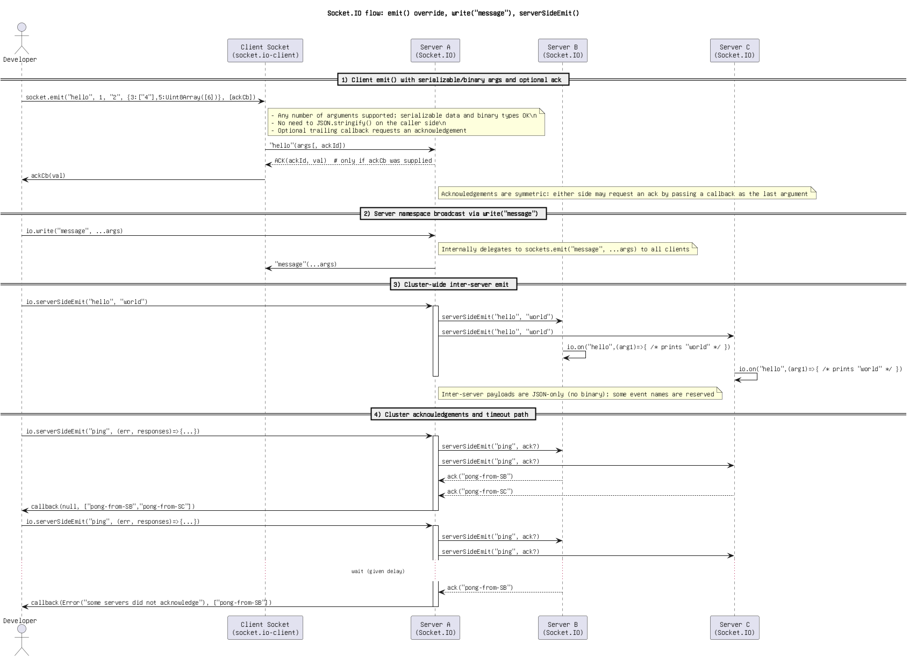

Figure 18: Socket.IO flow_ emit() override, write(_message_), serverSideEmit().png

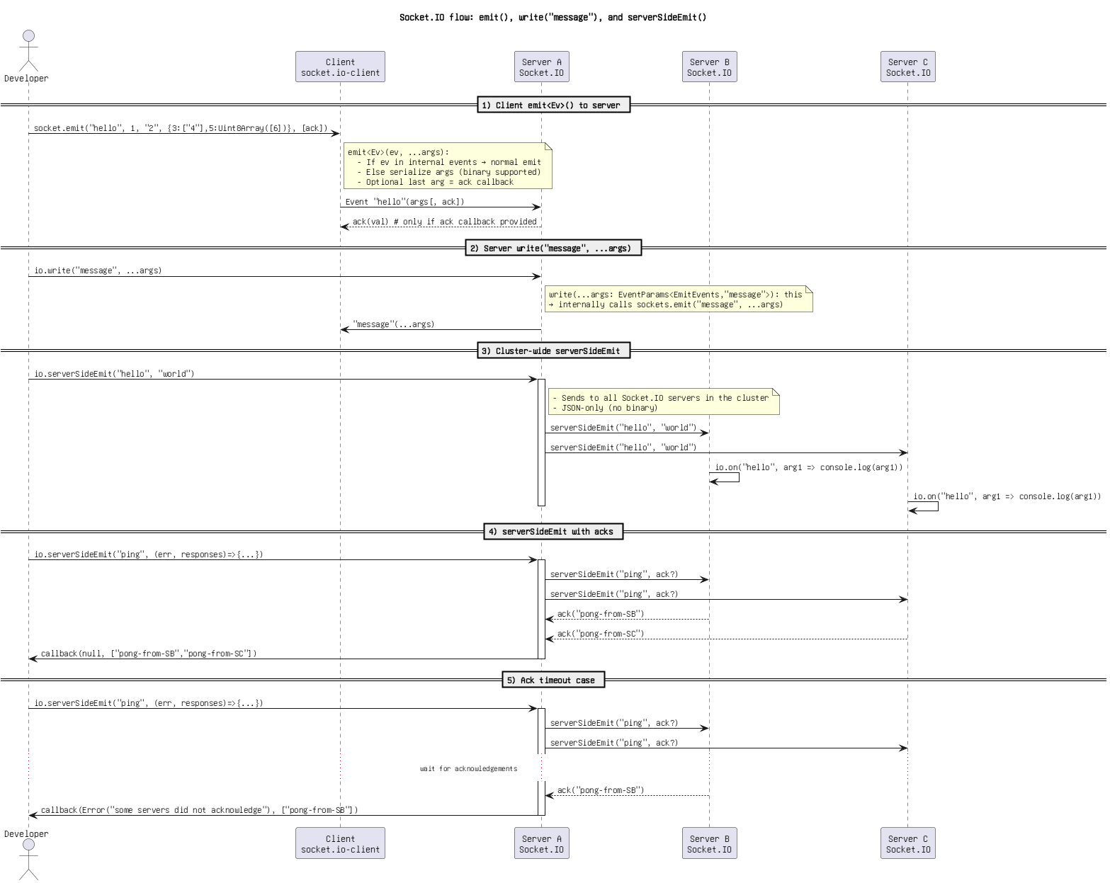

Figure 19: Socket.IO flow_ emit(), write(_message_), and serverSideEmit().png

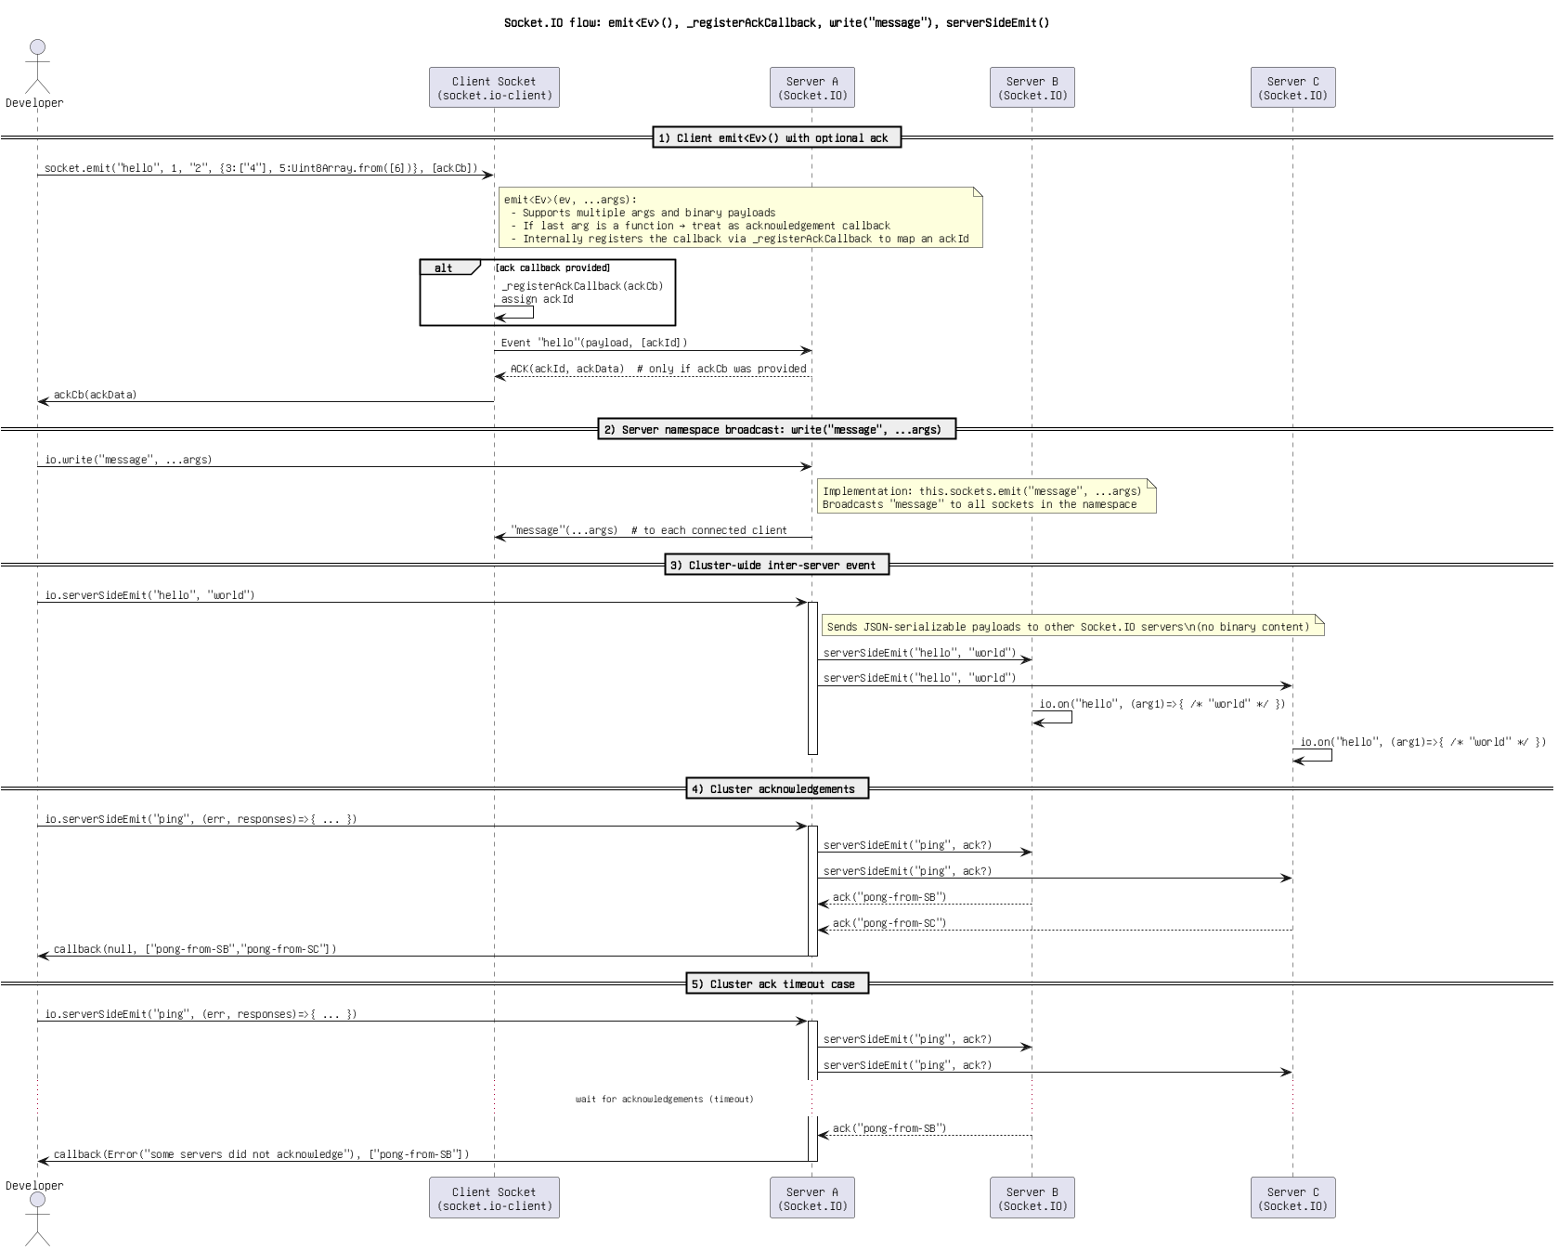

Figure 20: Socket.IO flow_ emit_Ev_(), _registerAckCallback, write(_message_), serverSideEmit(.png

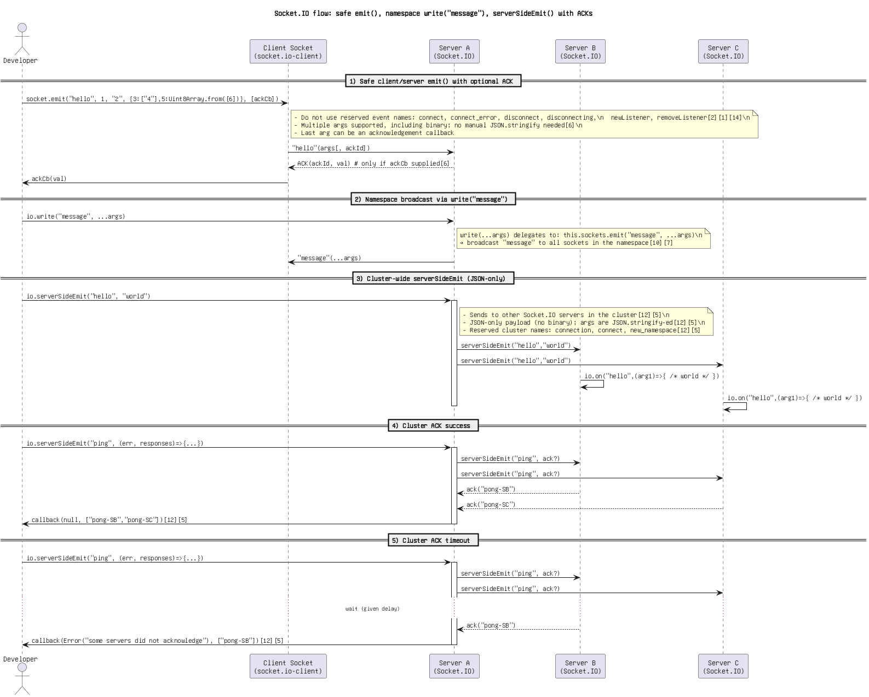

Figure 21: Socket.IO flow_ safe emit(), namespace write(_message_), serverSideEmit() with ACKs(1).png

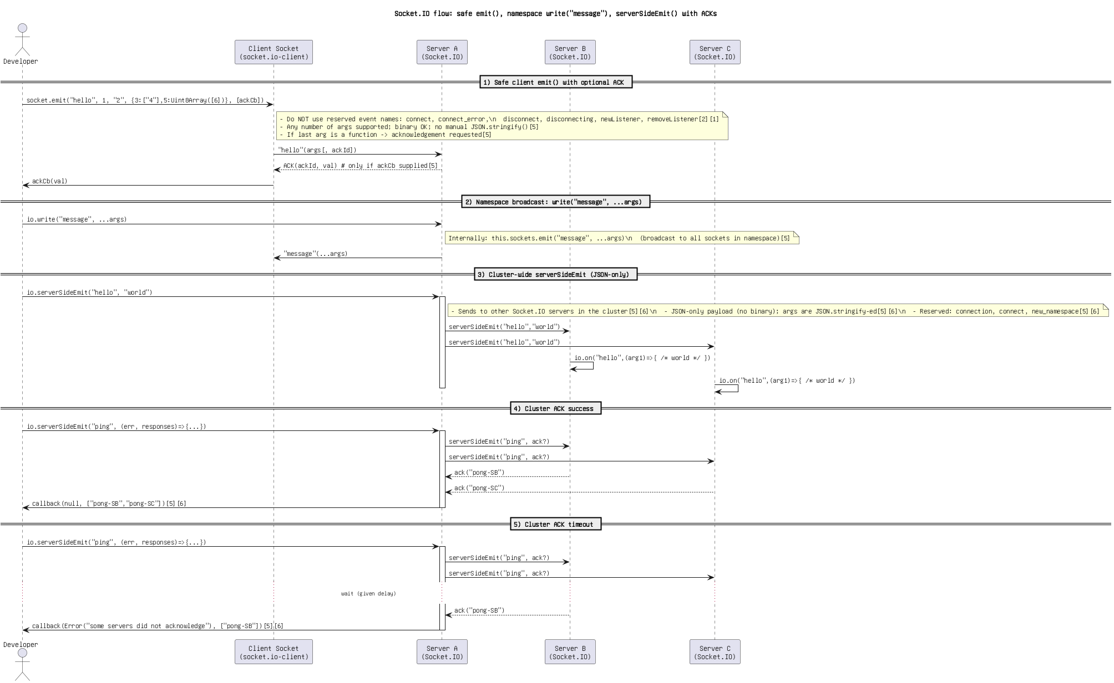

Figure 22: Socket.IO flow_ safe emit(), namespace write(_message_), serverSideEmit() with ACKs.png

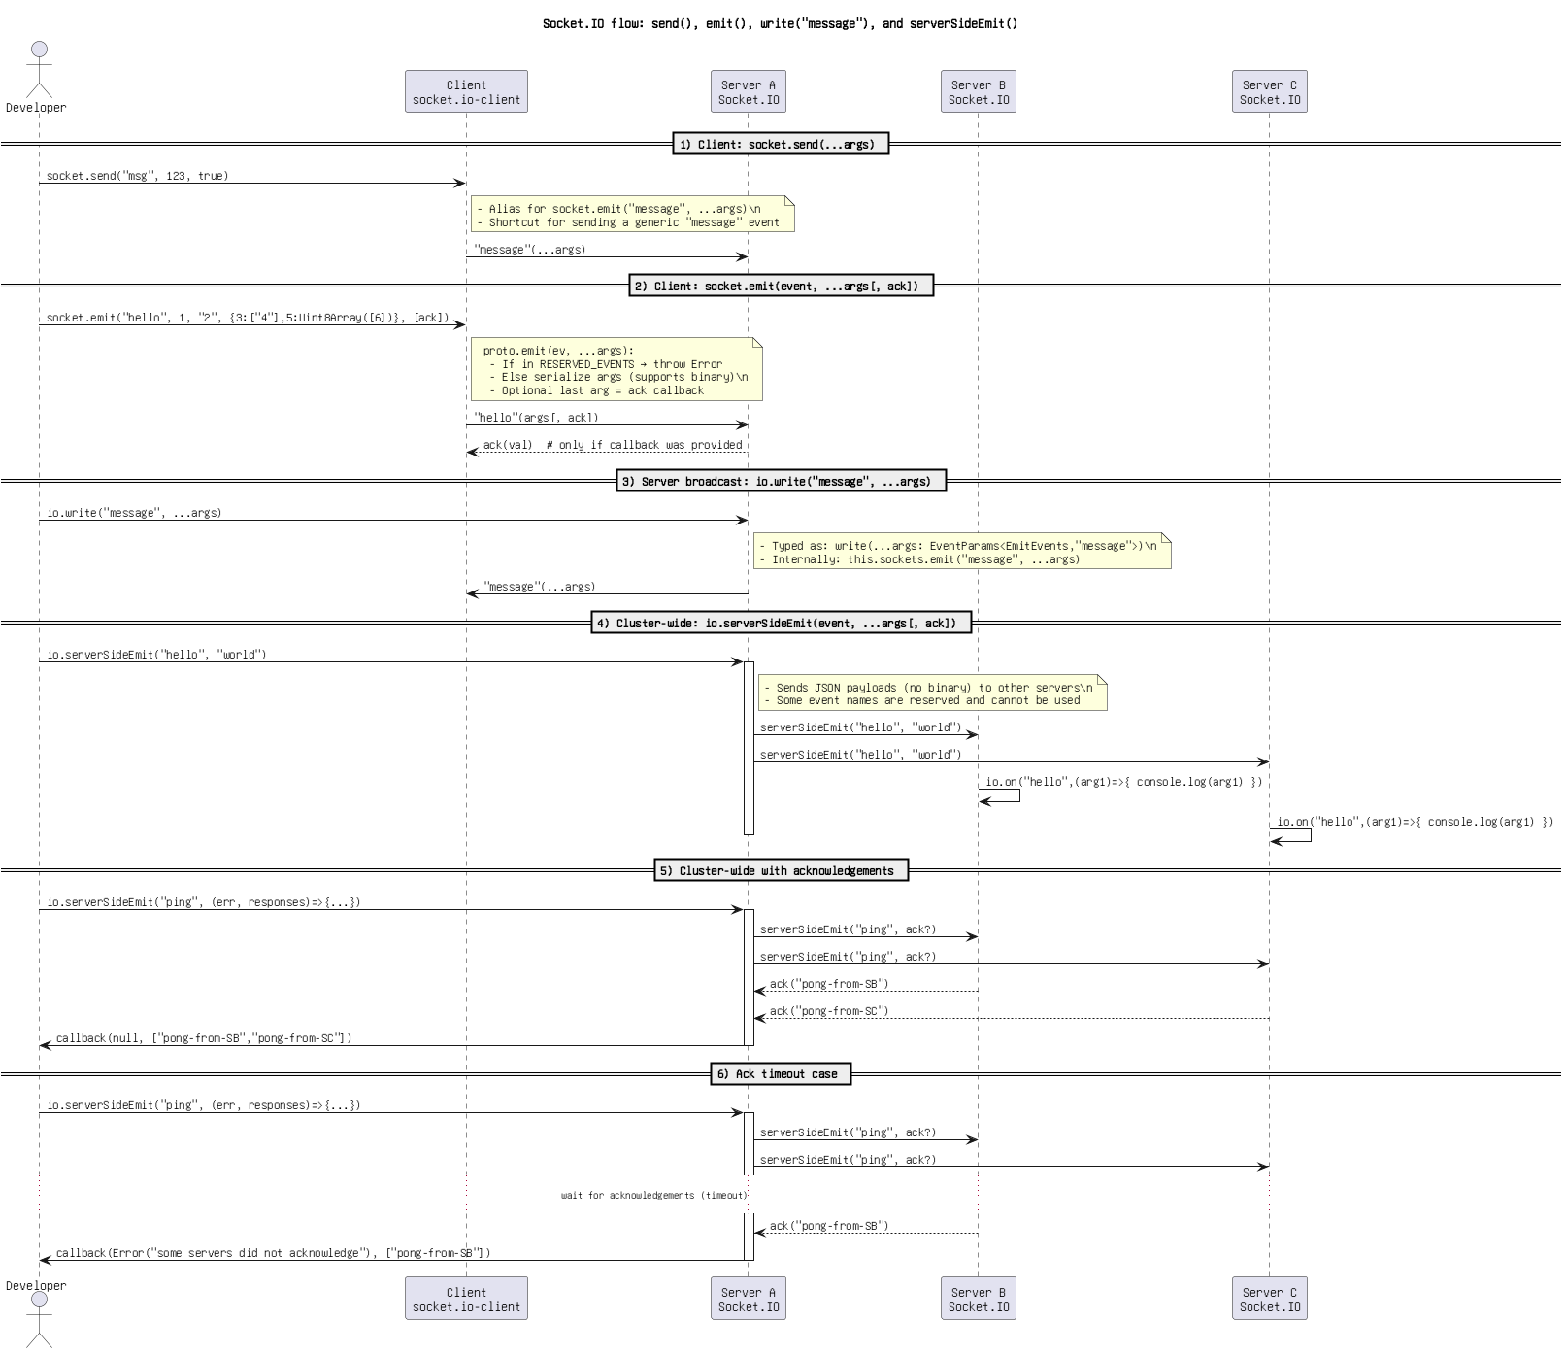

Figure 23: Socket.IO flow_ send(), emit(), write(_message_), and serverSideEmit().png

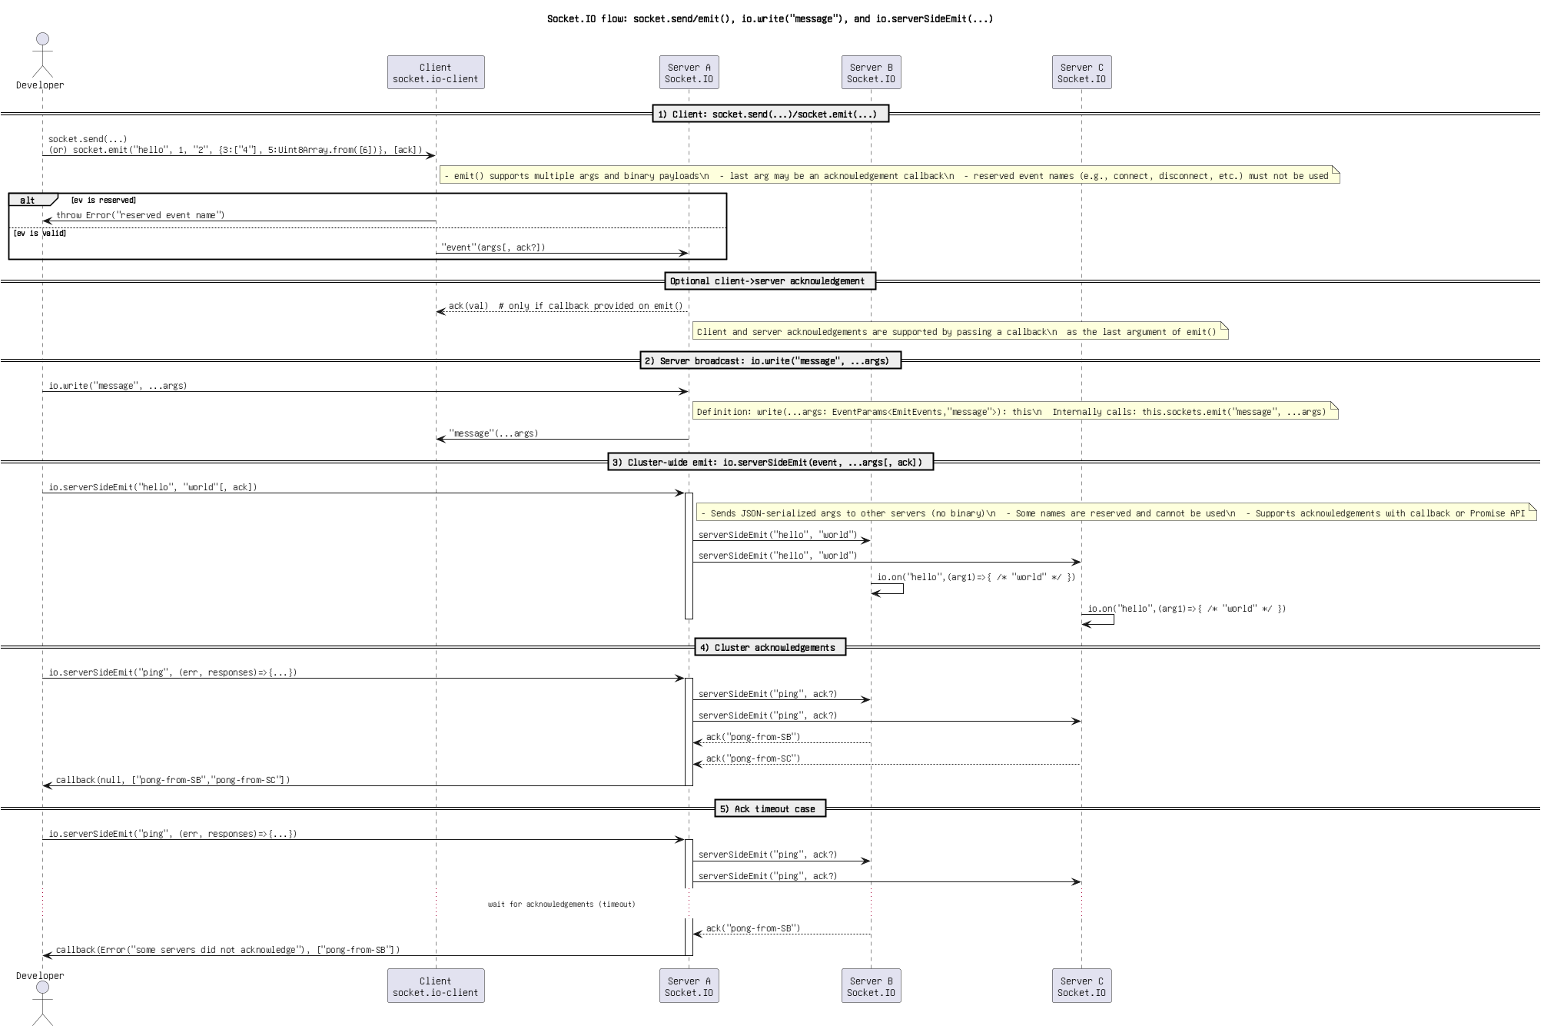

Figure 24: Socket.IO flow_ socket.send_emit(), io.write(_message_), and io.serverSideEmit(...).png

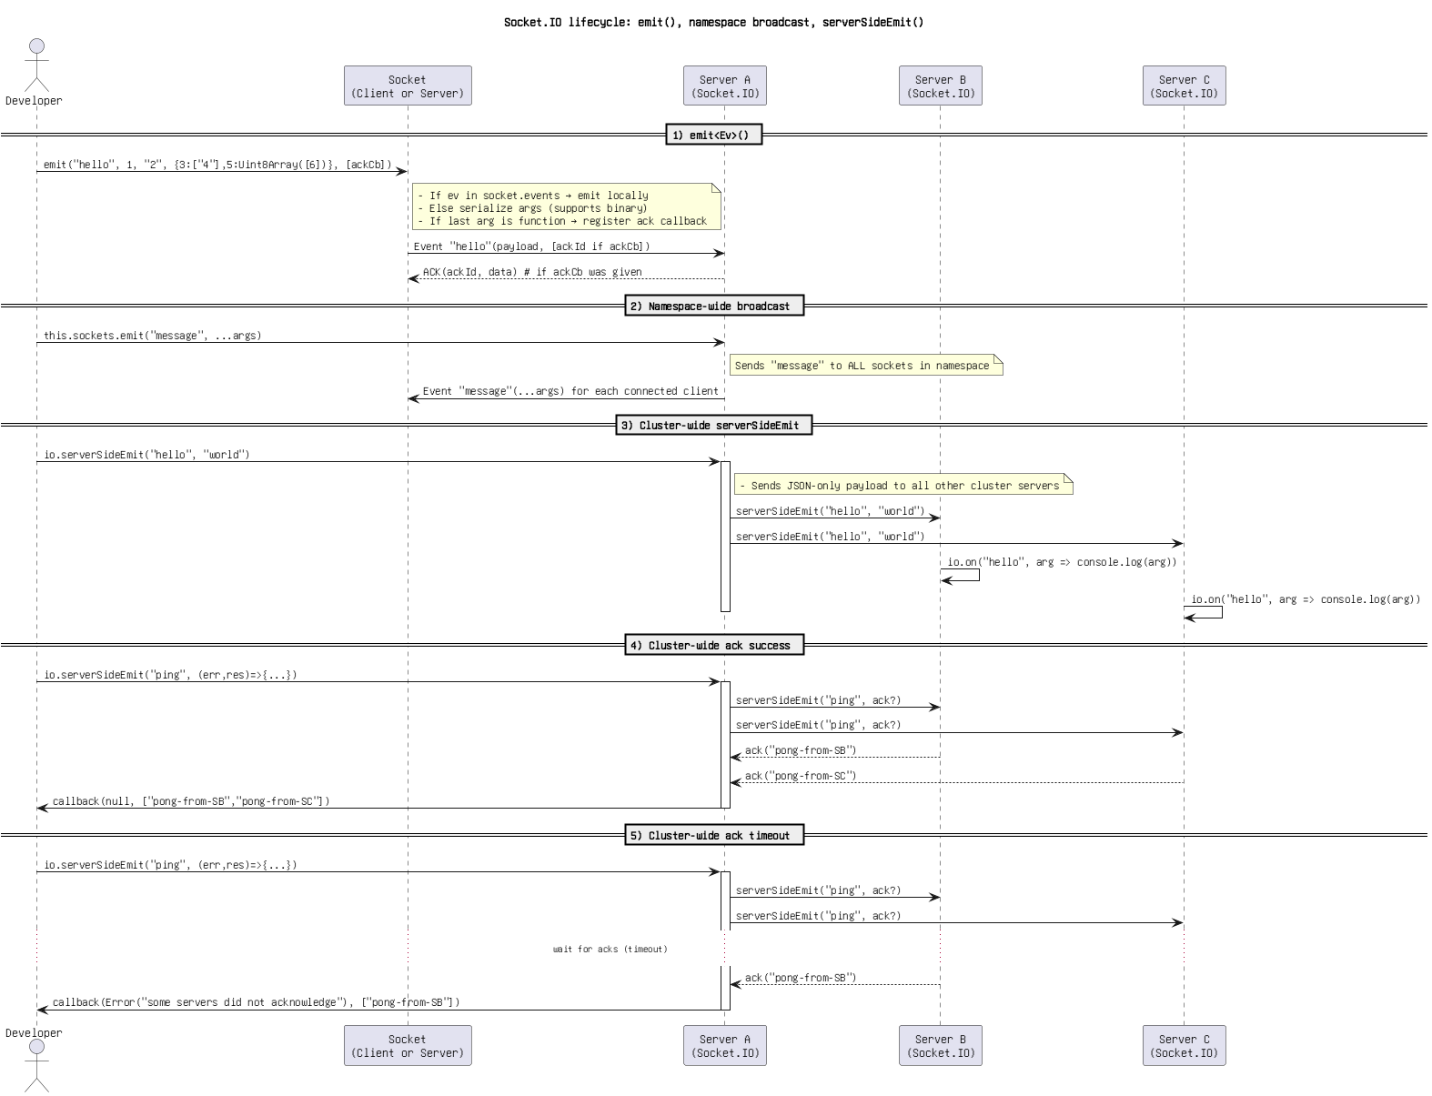

Figure 25: Socket.IO lifecycle_ emit(), namespace broadcast, serverSideEmit().png

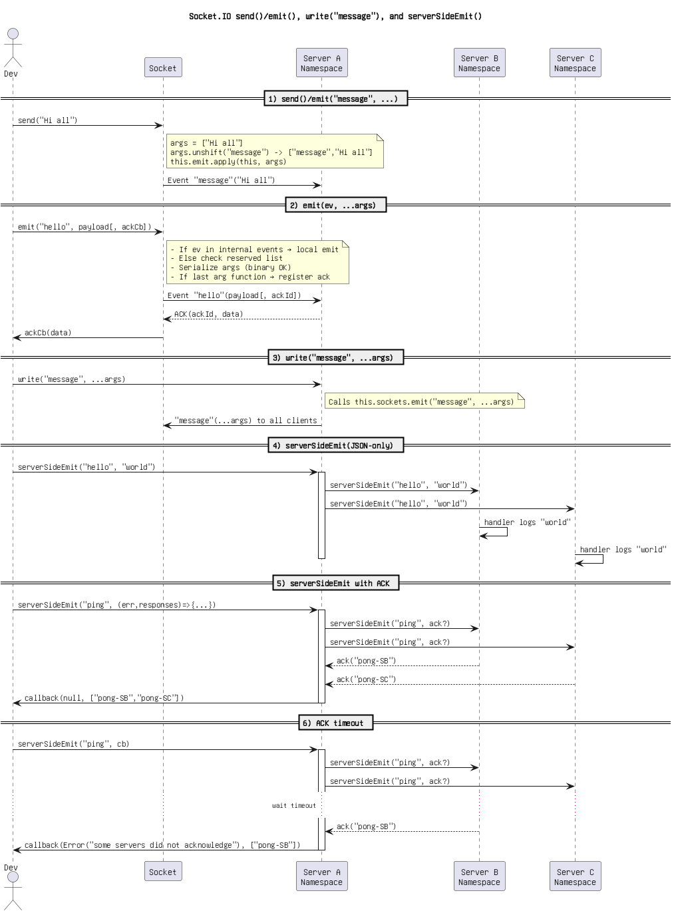

Figure 26: Socket.IO send()_emit(), write(_message_), and serverSideEmit().png

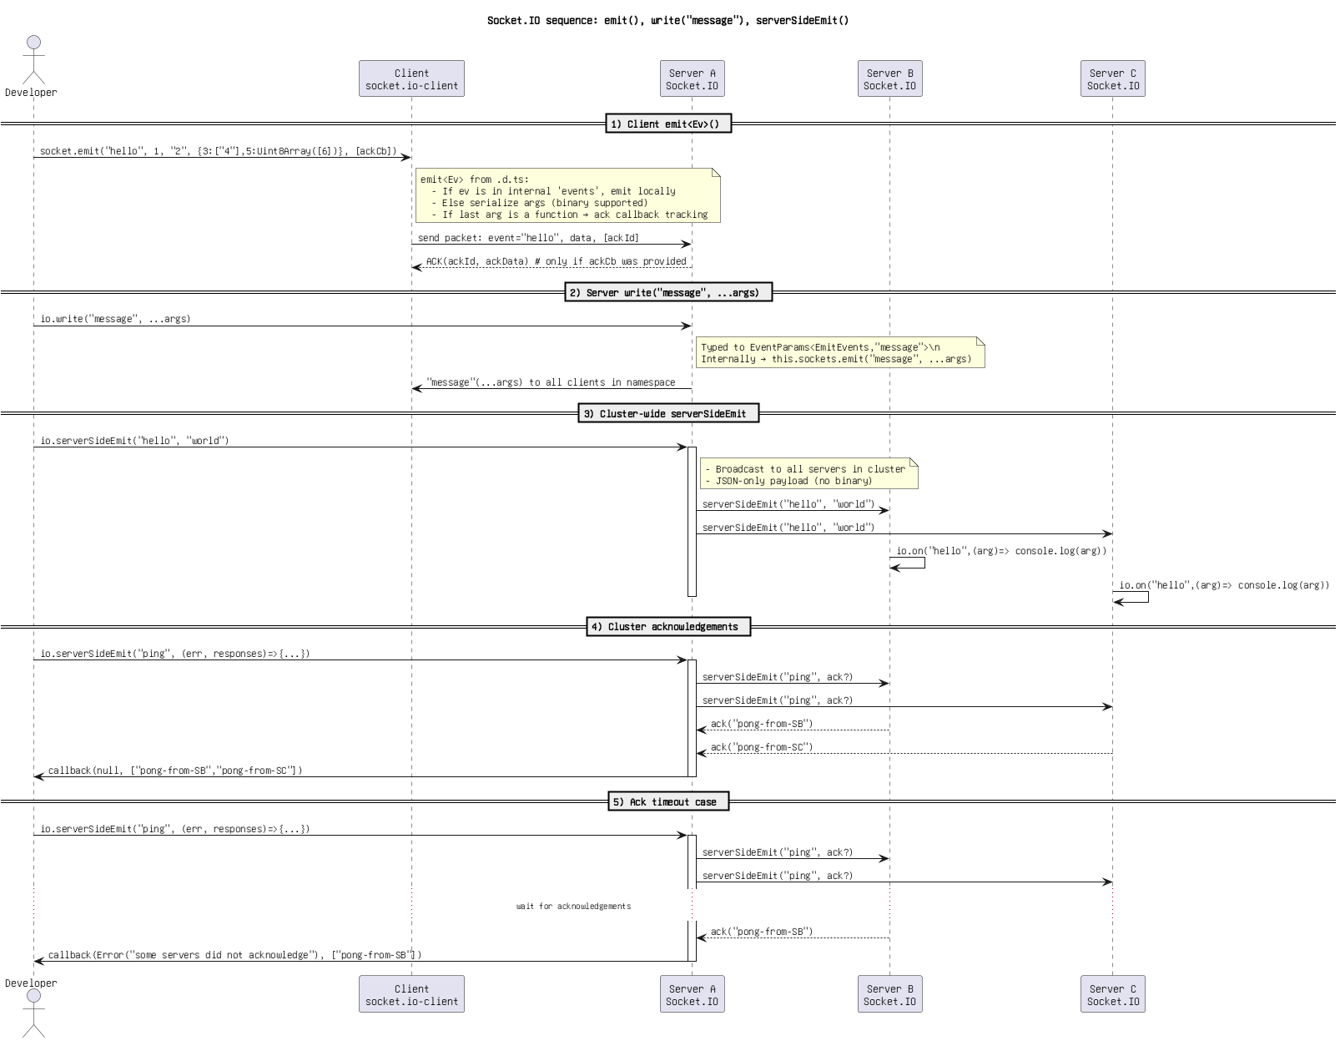

Figure 27: Socket.IO sequence_ emit(), write(_message_), serverSideEmit().png

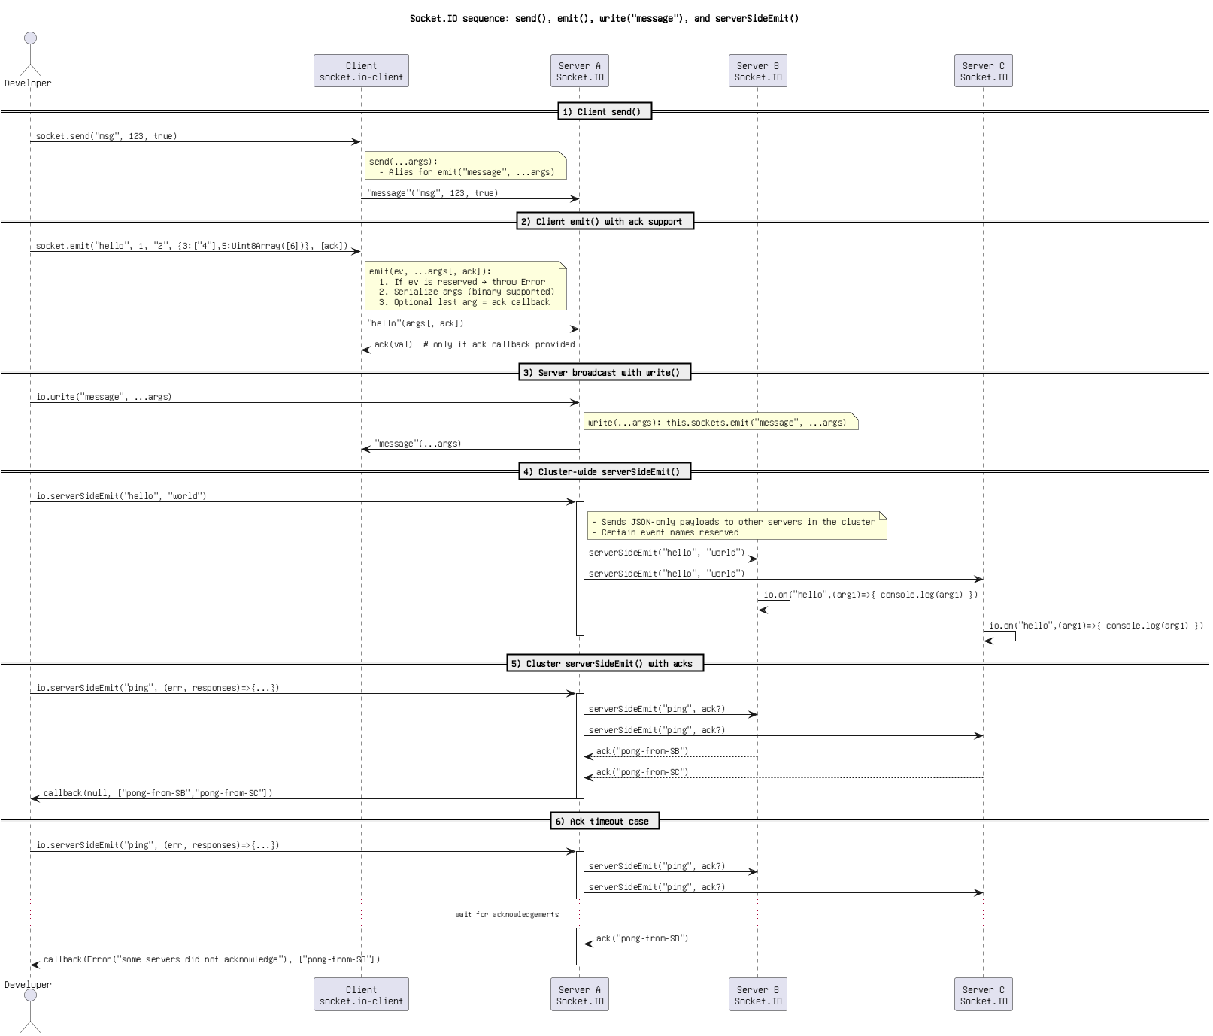

Figure 28: Socket.IO sequence_ send(), emit(), write(_message_), and serverSideEmit().png

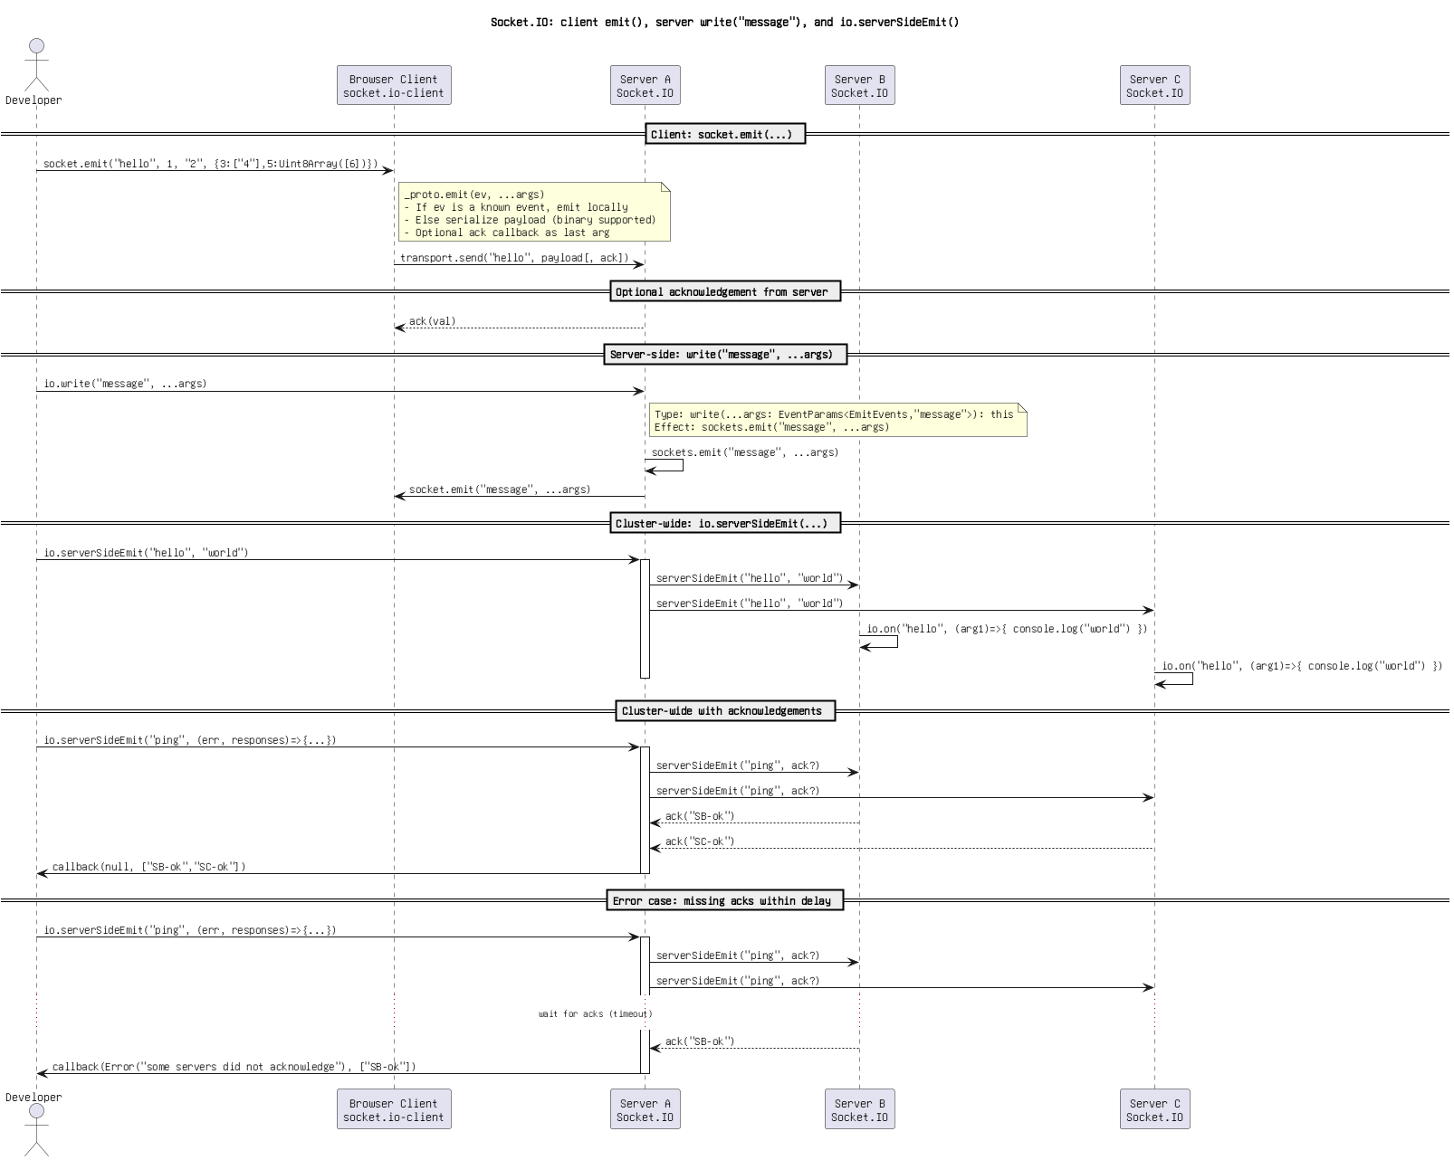

Figure 29: Socket.IO_ client emit(), server write(_message_), and io.serverSideEmit().png

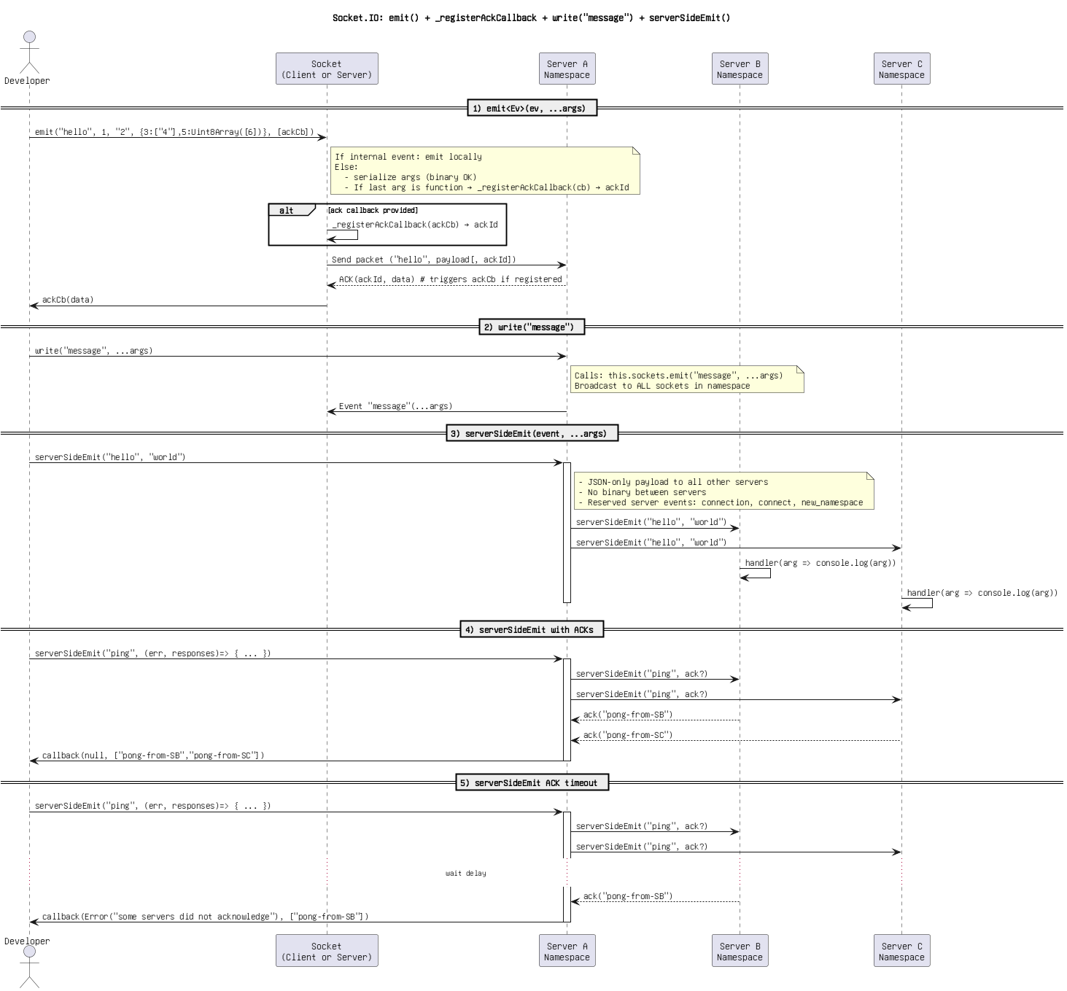

Figure 30: Socket.IO_ emit() + _registerAckCallback + write(_message_) + serverSideEmit().png

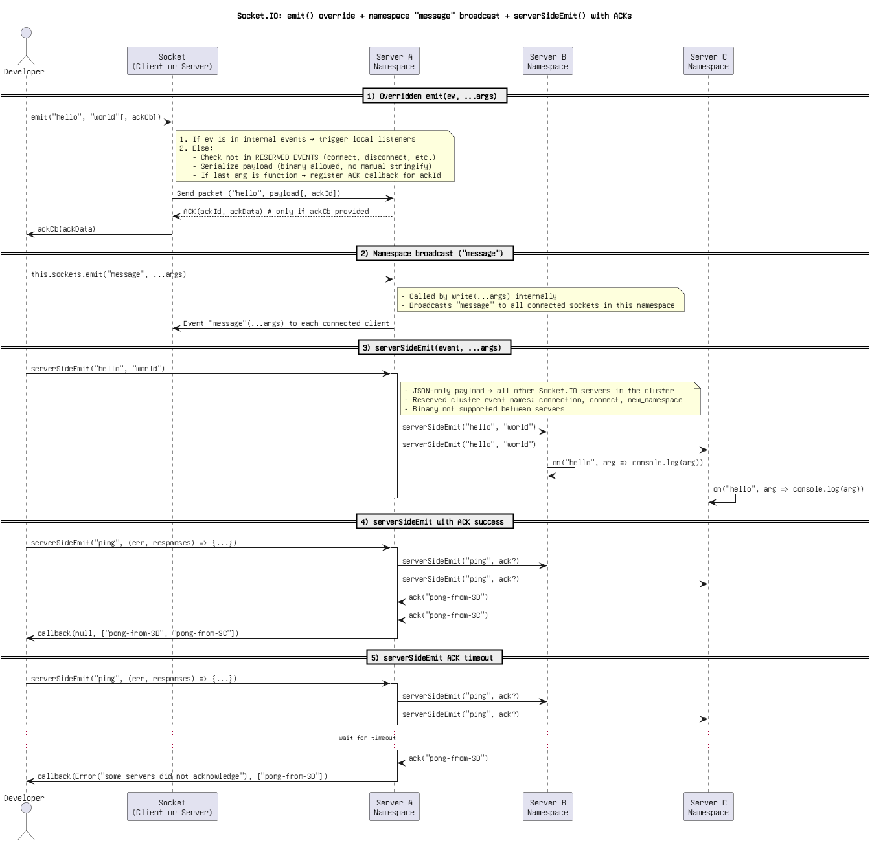

Figure 31: Socket.IO_ emit() override + namespace _message_ broadcast + serverSideEmit() with ACKs.png

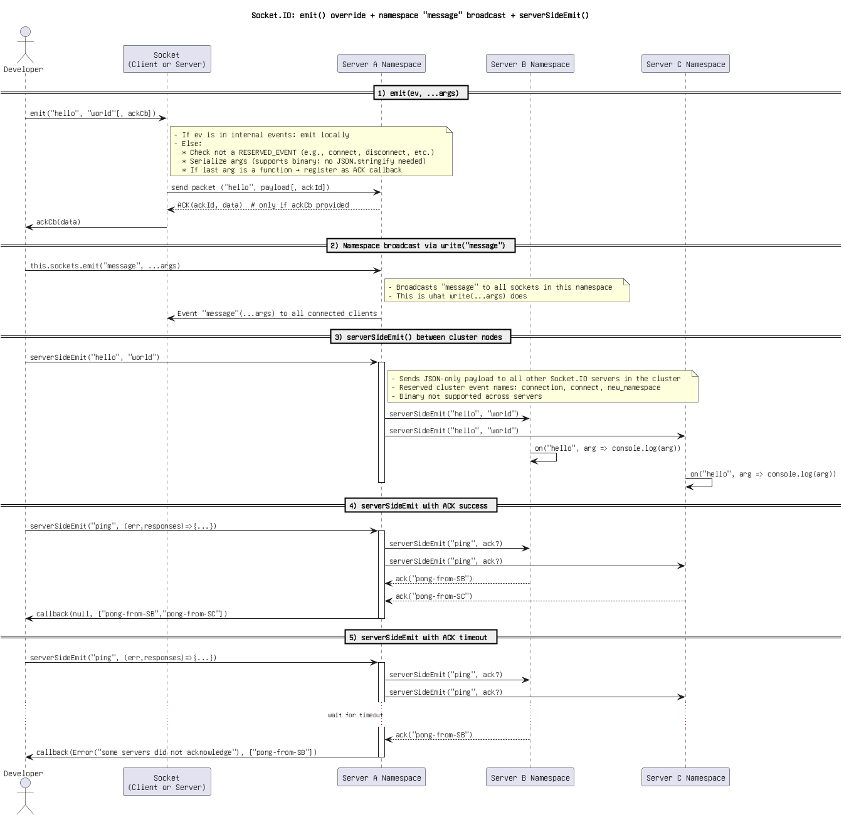

Figure 32: Socket.IO_ emit() override + namespace _message_ broadcast + serverSideEmit().png

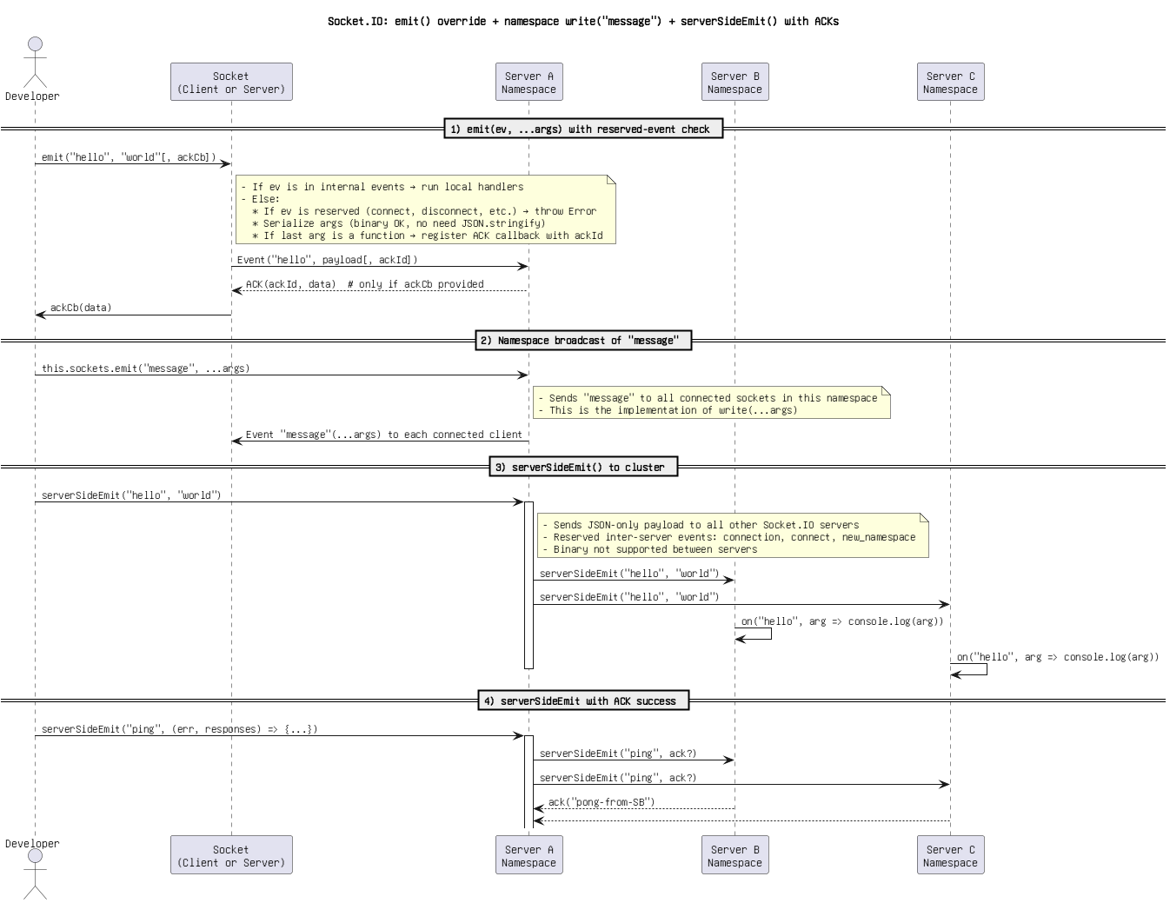

Figure 33: Socket.IO_ emit() override + namespace write(_message_) + serverSideEmit() with ACKs.png

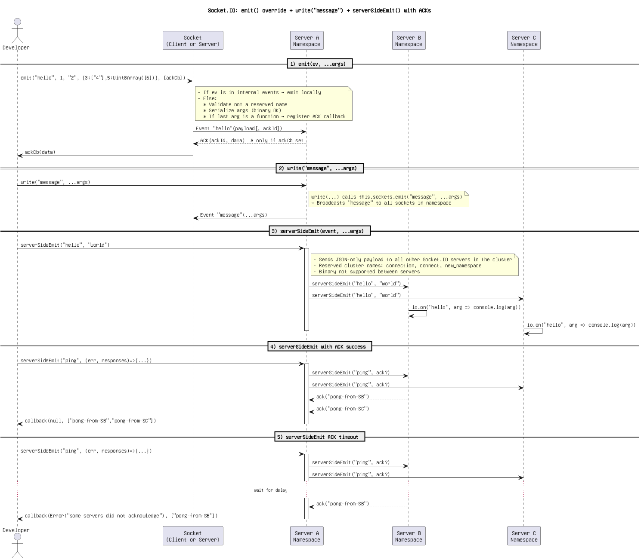

Figure 34: Socket.IO_ emit() override + write(_message_) + serverSideEmit() with ACKs(1).png

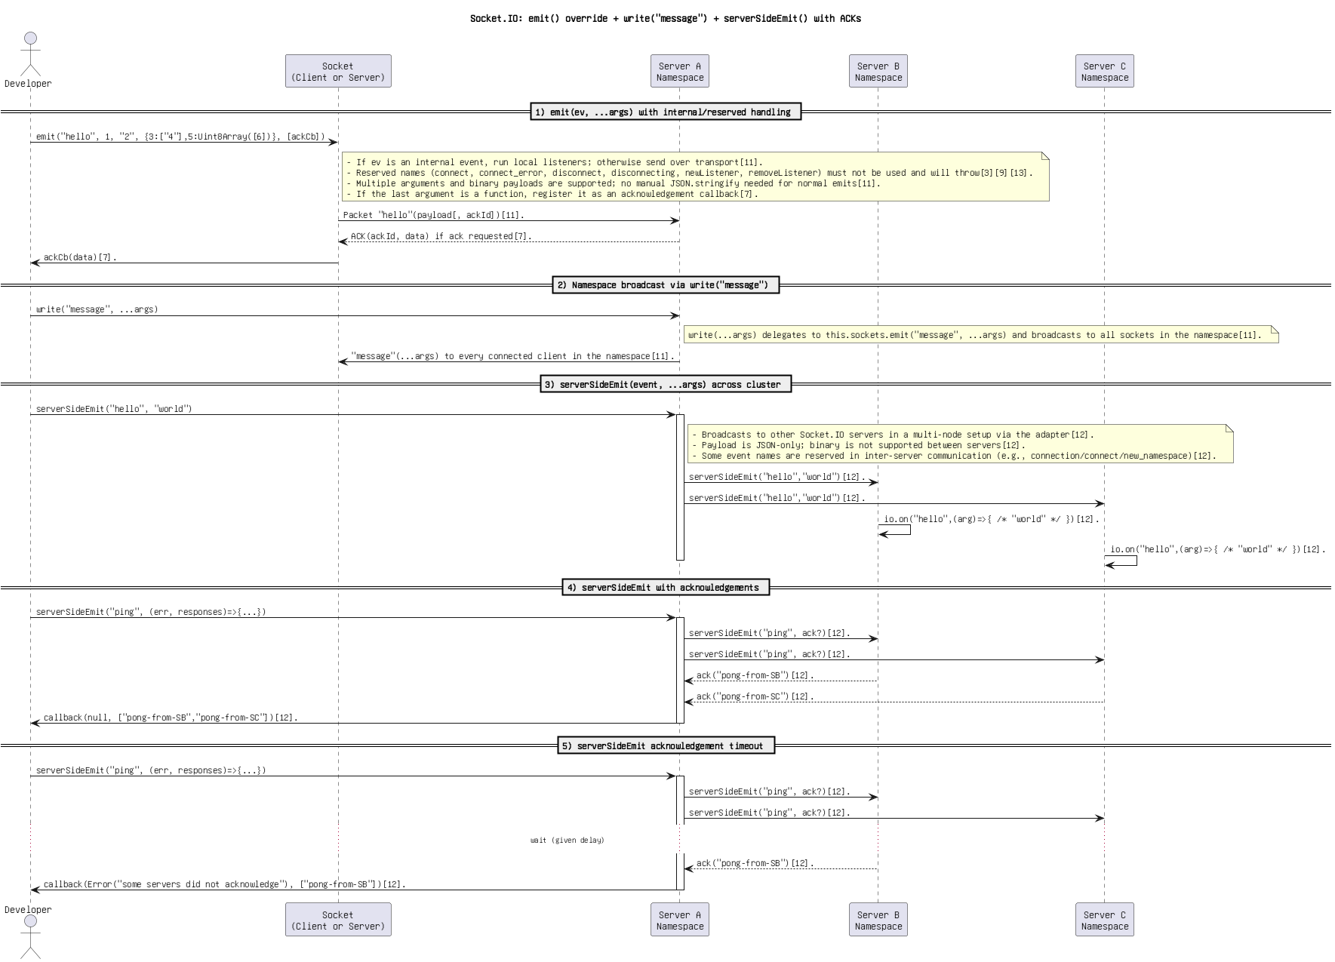

Figure 35: Socket.IO_ emit() override + write(_message_) + serverSideEmit() with ACKs(2).png

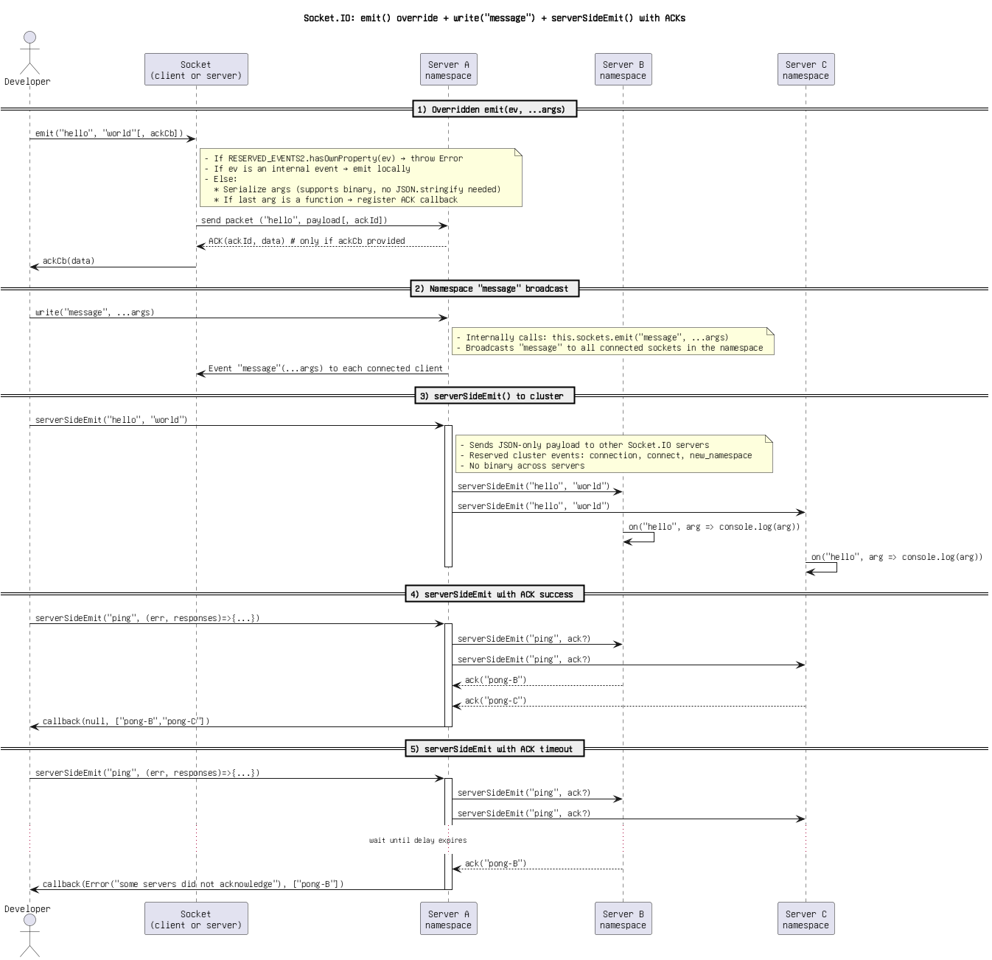

Figure 36: Socket.IO_ emit() override + write(_message_) + serverSideEmit() with ACKs(3).png

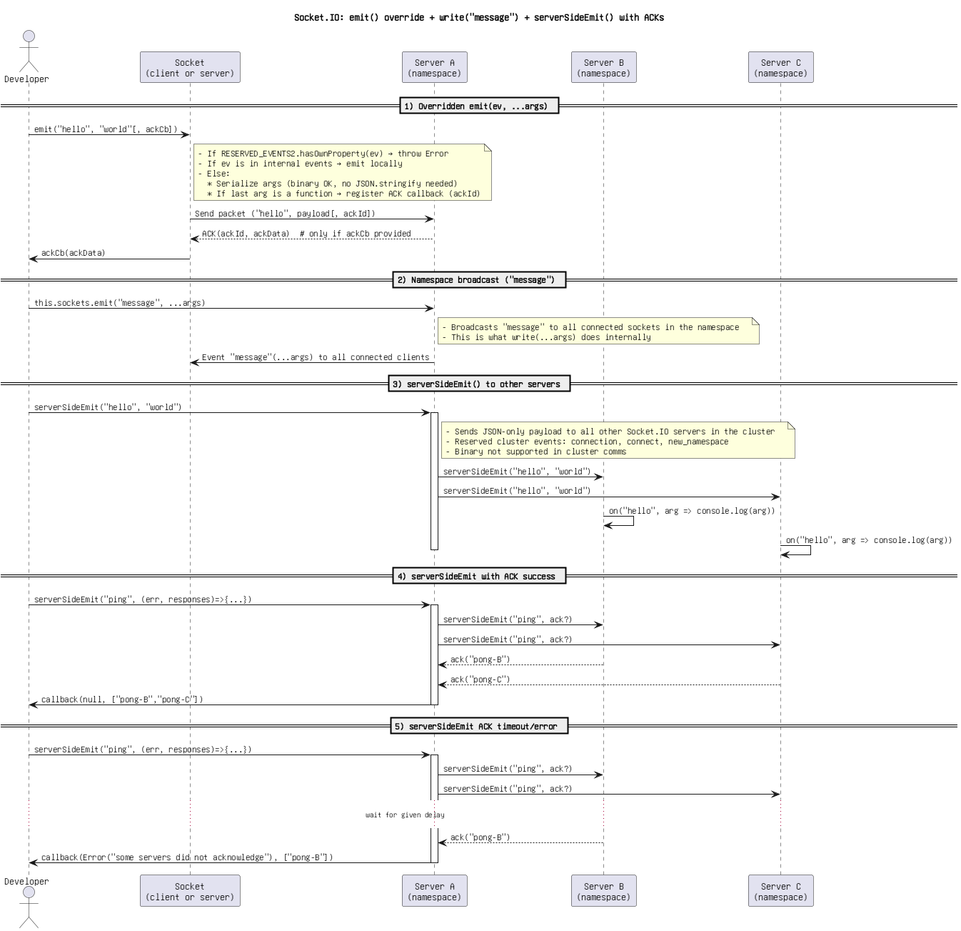

Figure 37: Socket.IO_ emit() override + write(_message_) + serverSideEmit() with ACKs(4) (Copy).png



Figure 38: Socket.IO_ emit() override + write(_message_) + serverSideEmit() with ACKs(4).png

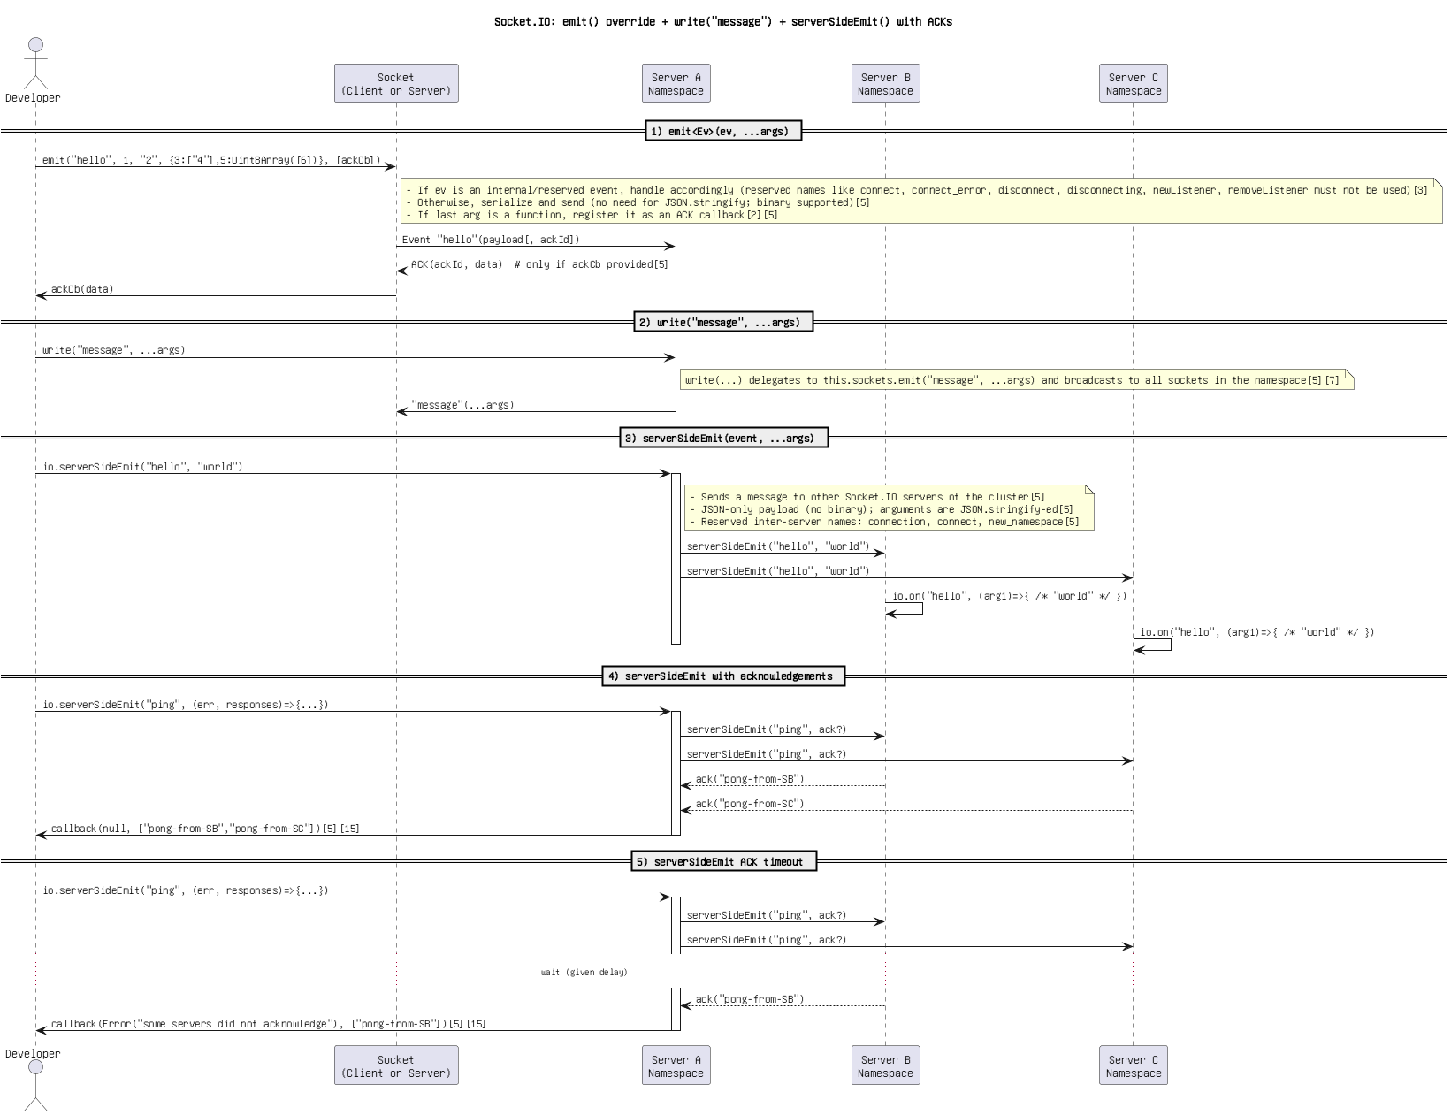

Figure 39: Socket.IO_ emit() override + write(_message_) + serverSideEmit() with ACKs..png

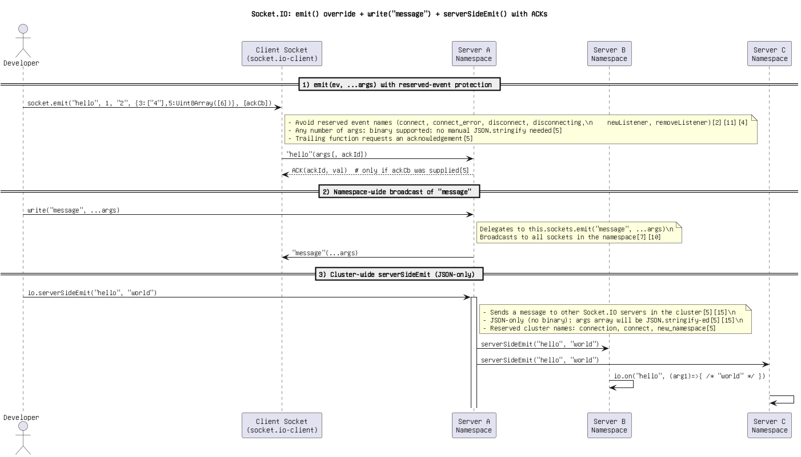

Figure 40: Socket.IO_ emit() override + write(_message_) + serverSideEmit() with ACKs.png

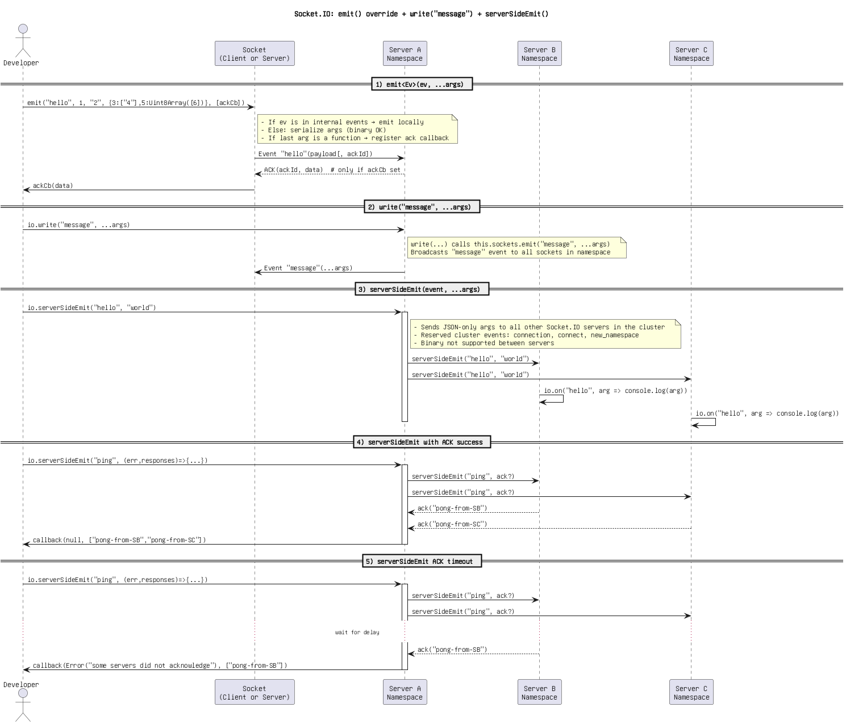

Figure 41: Socket.IO_ emit() override + write(_message_) + serverSideEmit()(1).png

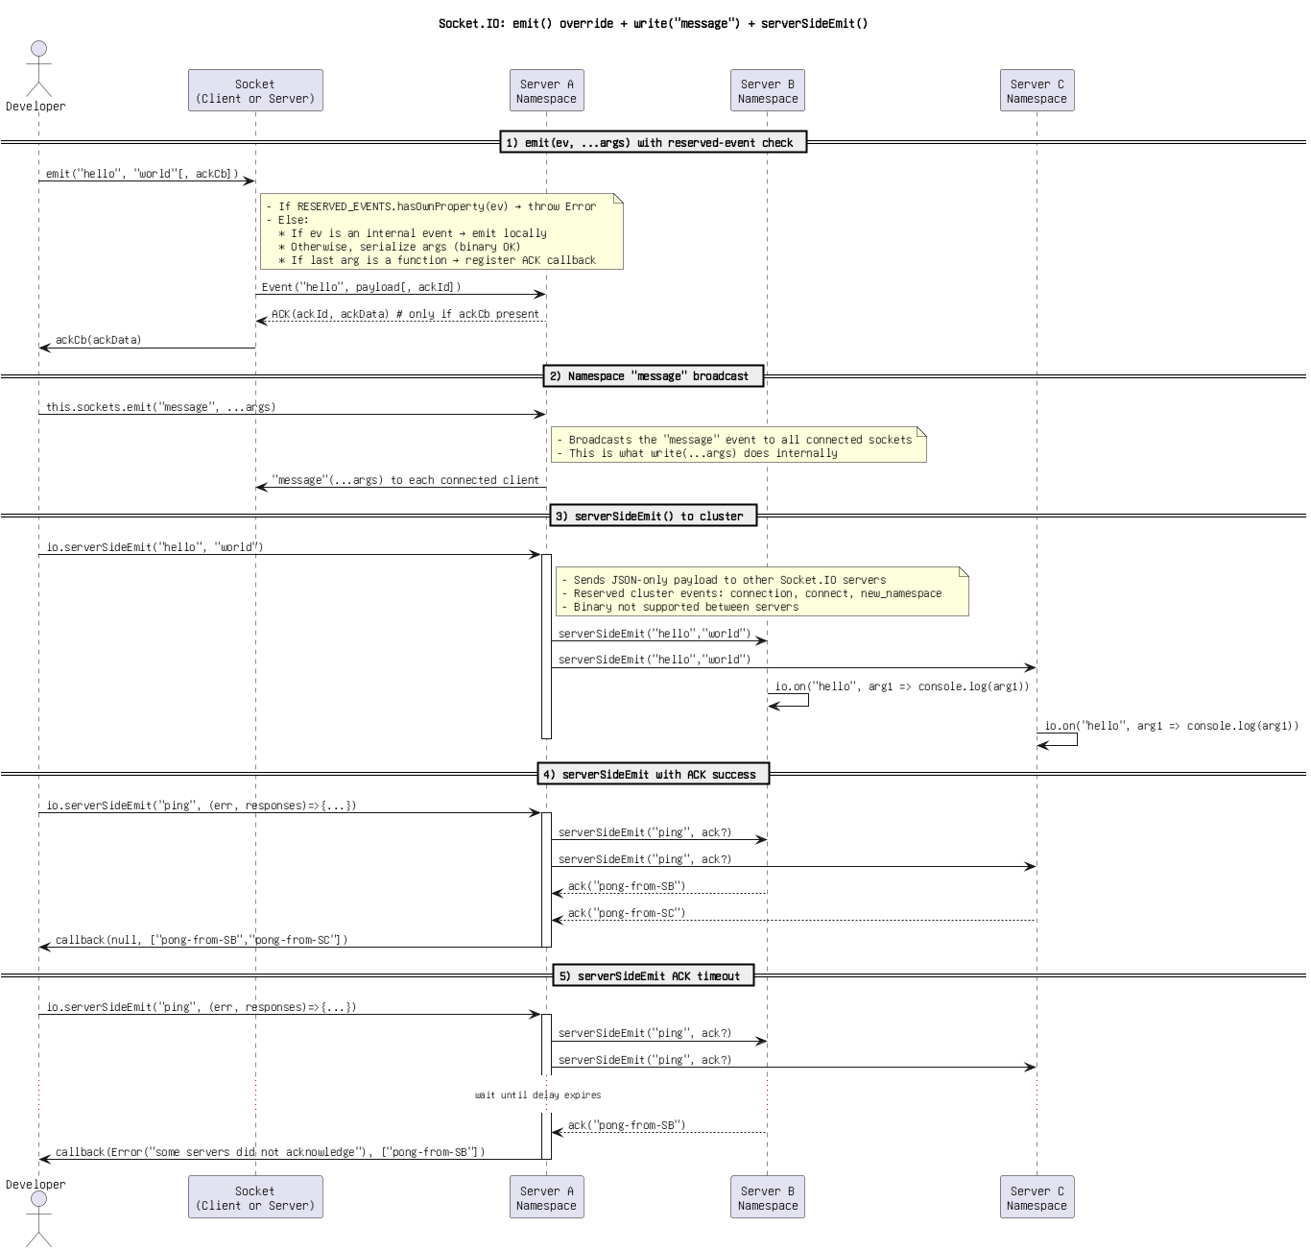

Figure 42: Socket.IO_ emit() override + write(_message_) + serverSideEmit()(2).png

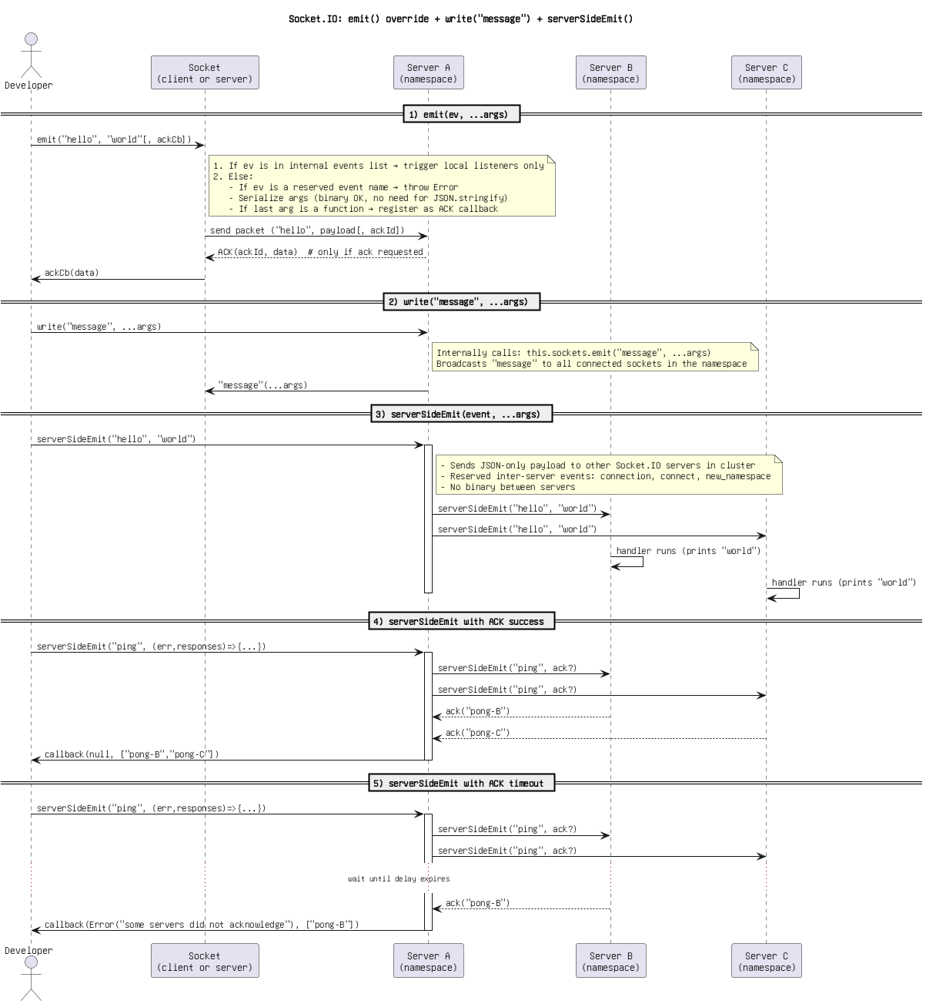

Figure 43: Socket.IO_ emit() override + write(_message_) + serverSideEmit()(3).png

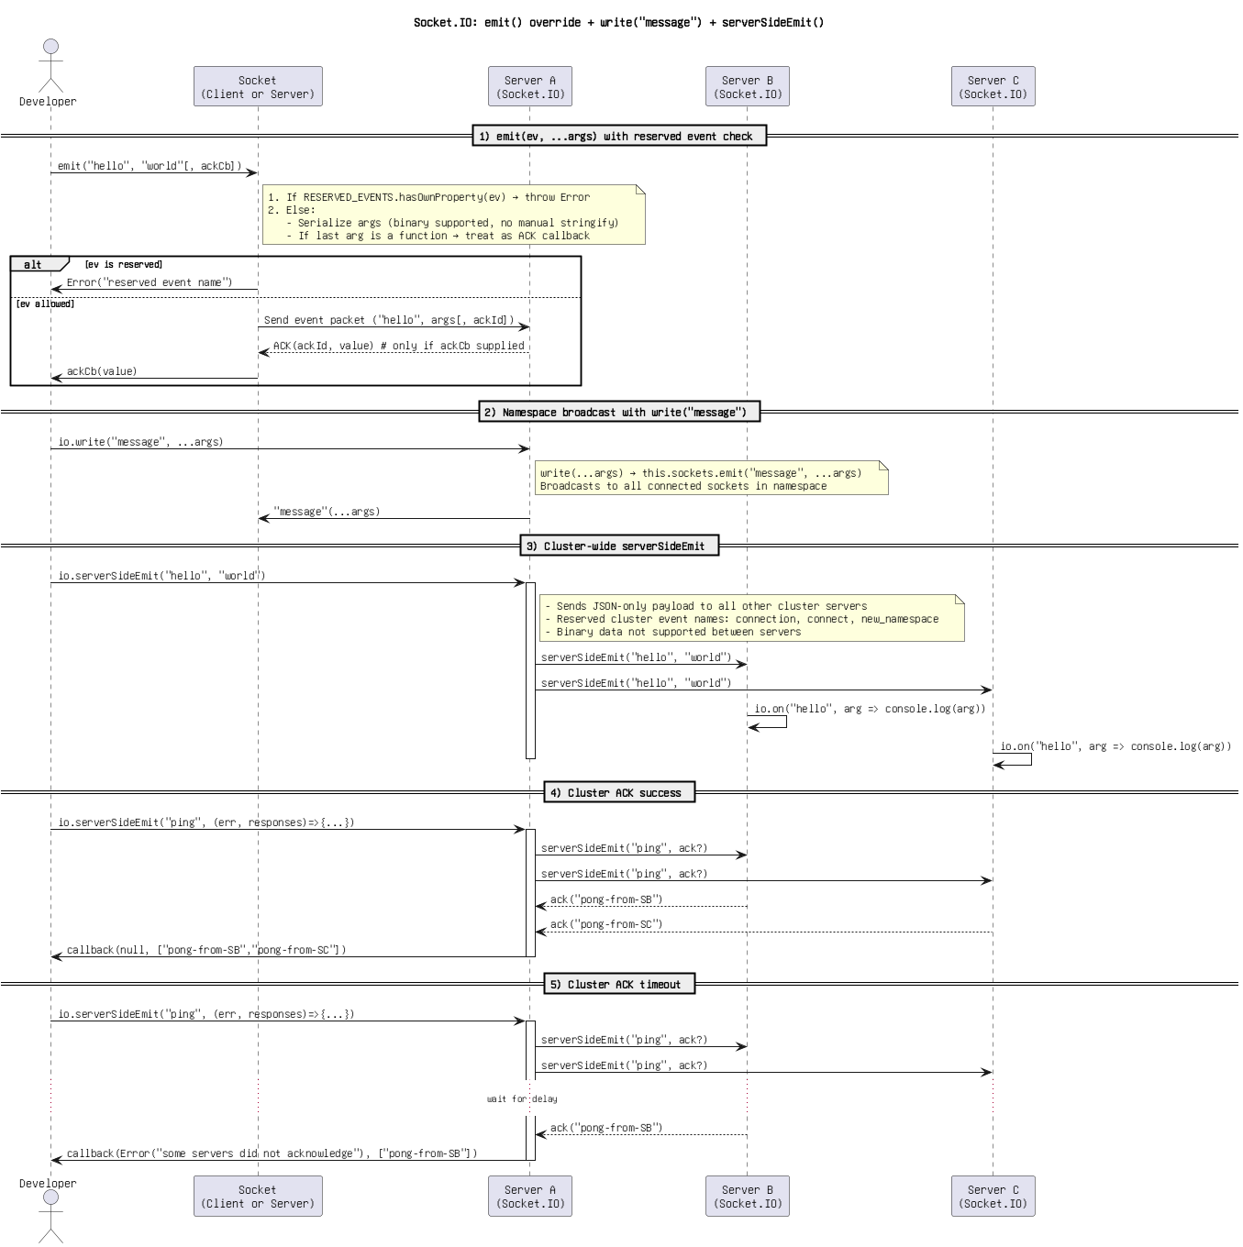

Figure 44: Socket.IO_ emit() override + write(_message_) + serverSideEmit().png

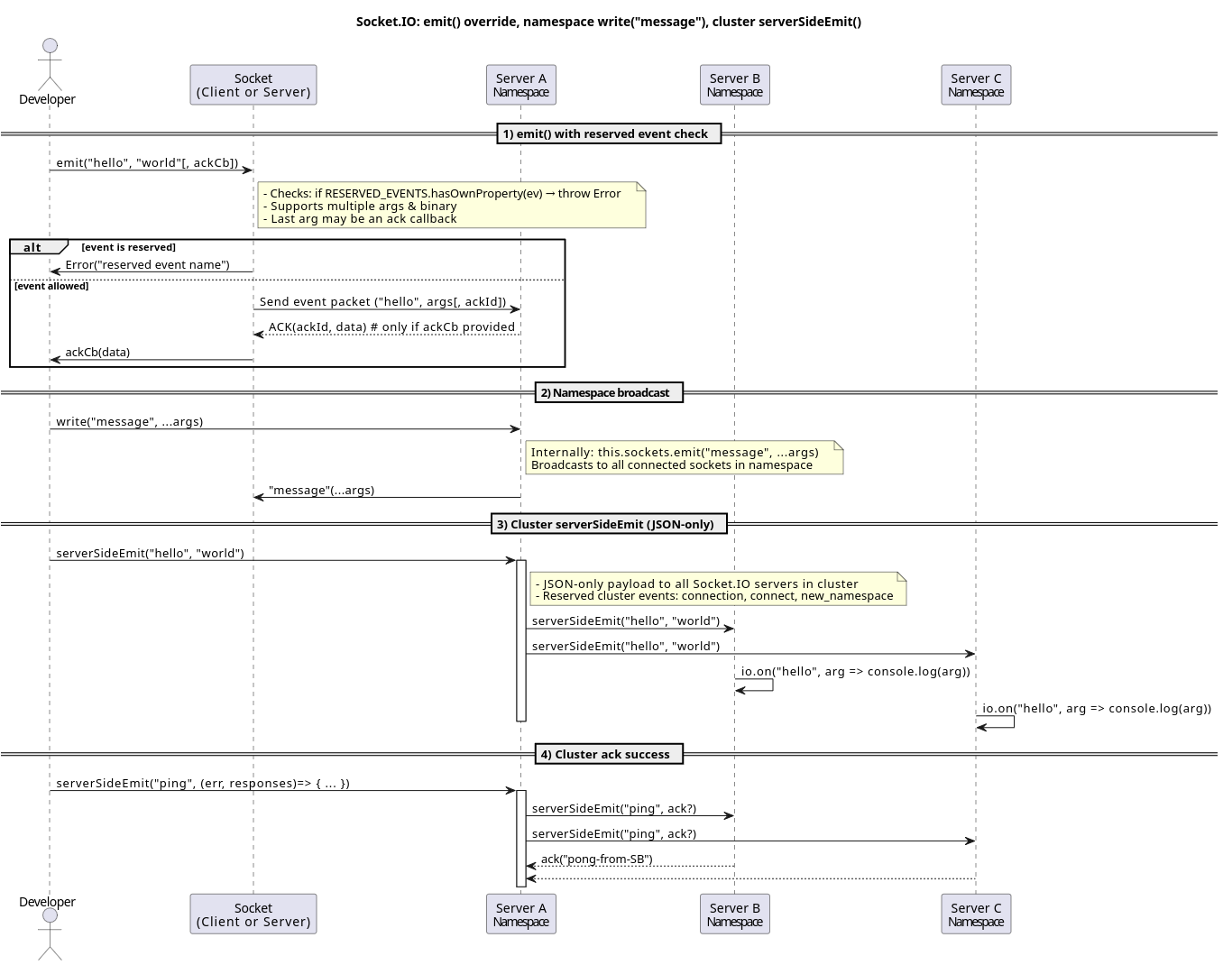

Figure 45: Socket.IO_ emit() override, namespace write(_message_), cluster serverSideEmit().png

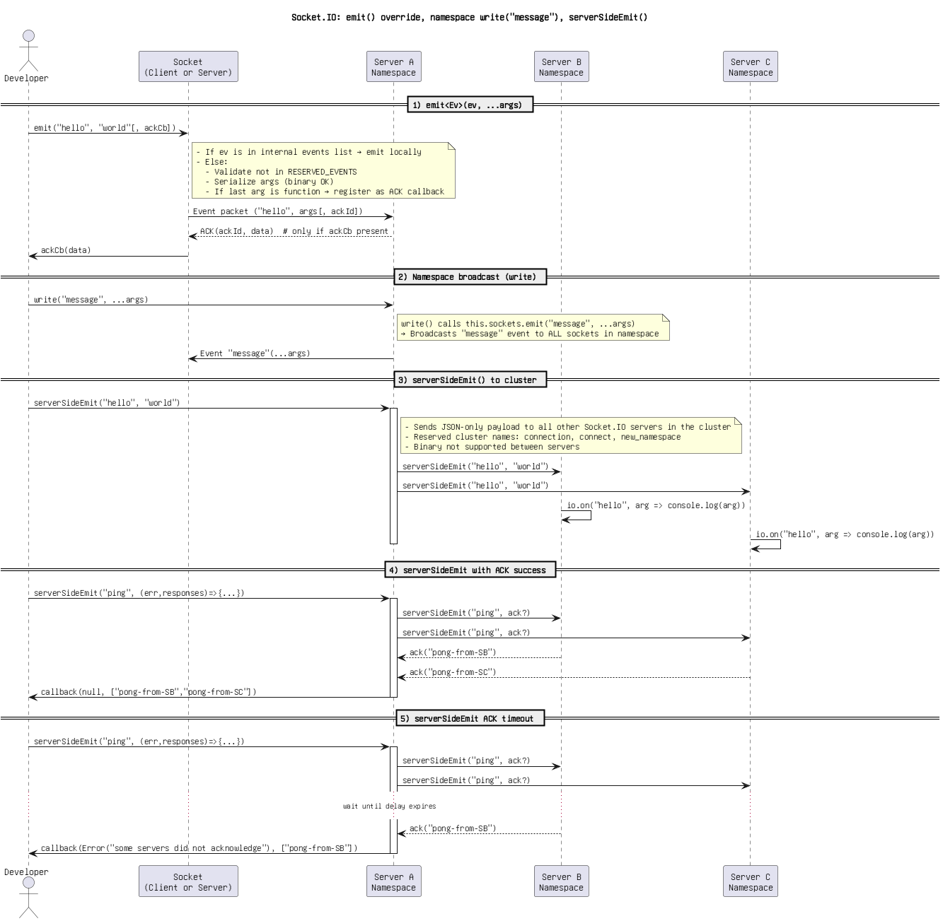

Figure 46: Socket.IO_ emit() override, namespace write(_message_), serverSideEmit().png

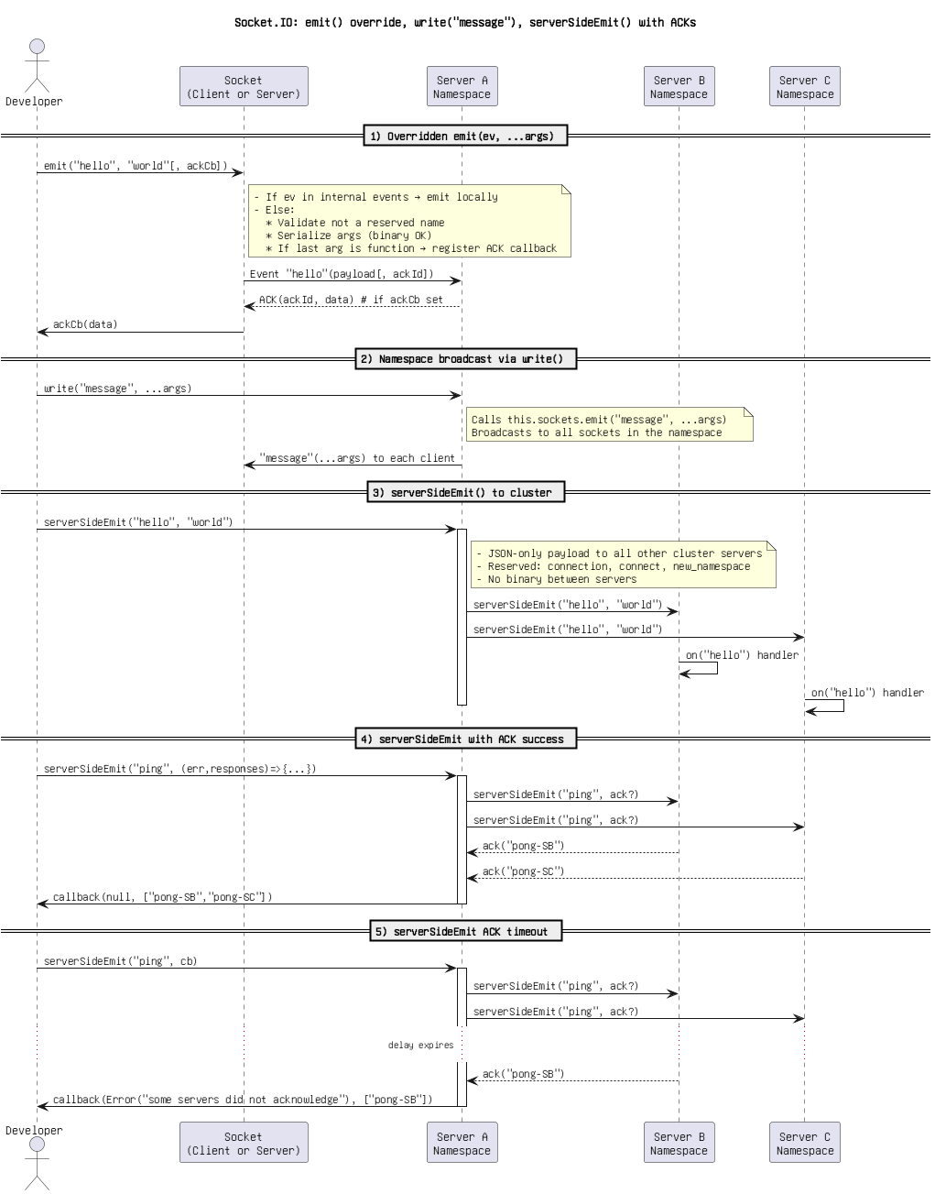

Figure 47: Socket.IO_ emit() override, write(_message_), serverSideEmit() with ACKs.png

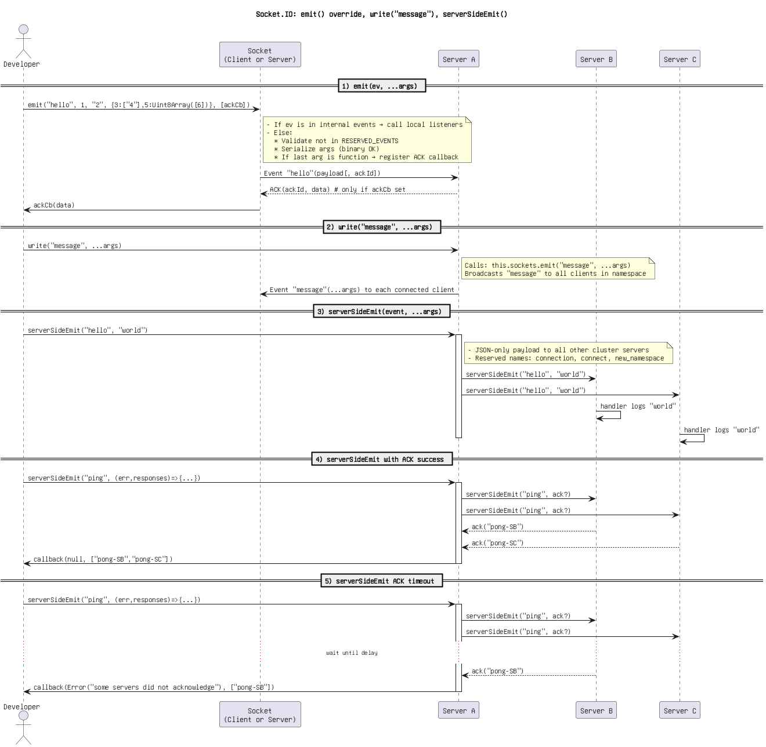

Figure 48: Socket.IO_ emit() override, write(_message_), serverSideEmit().png

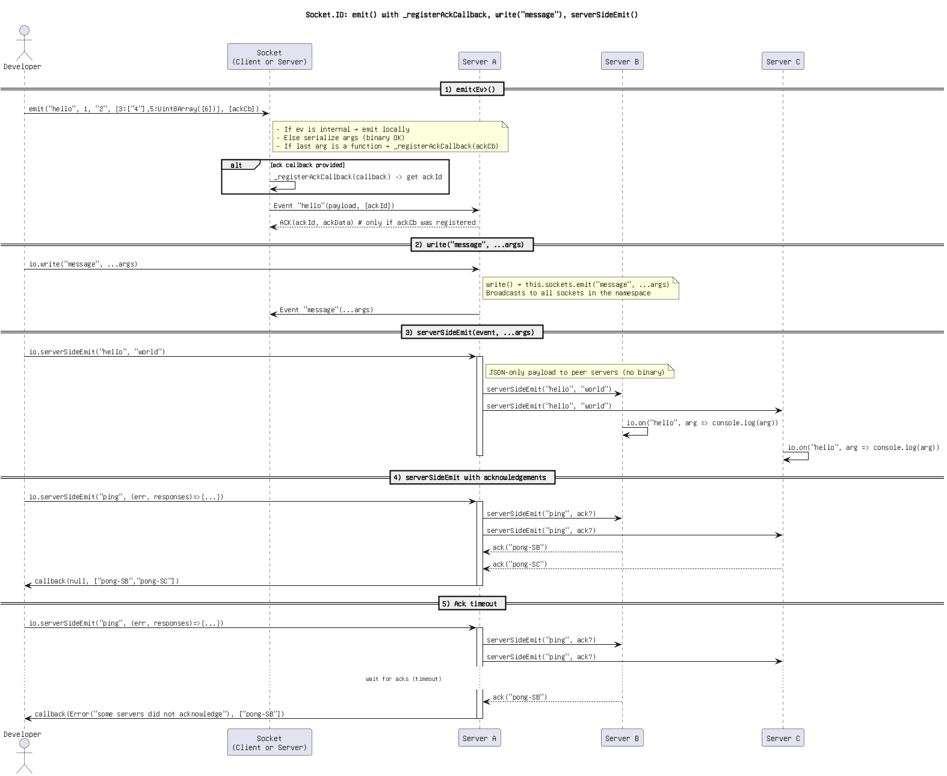

Figure 49: Socket.IO_ emit() with _registerAckCallback, write(_message_), serverSideEmit().png

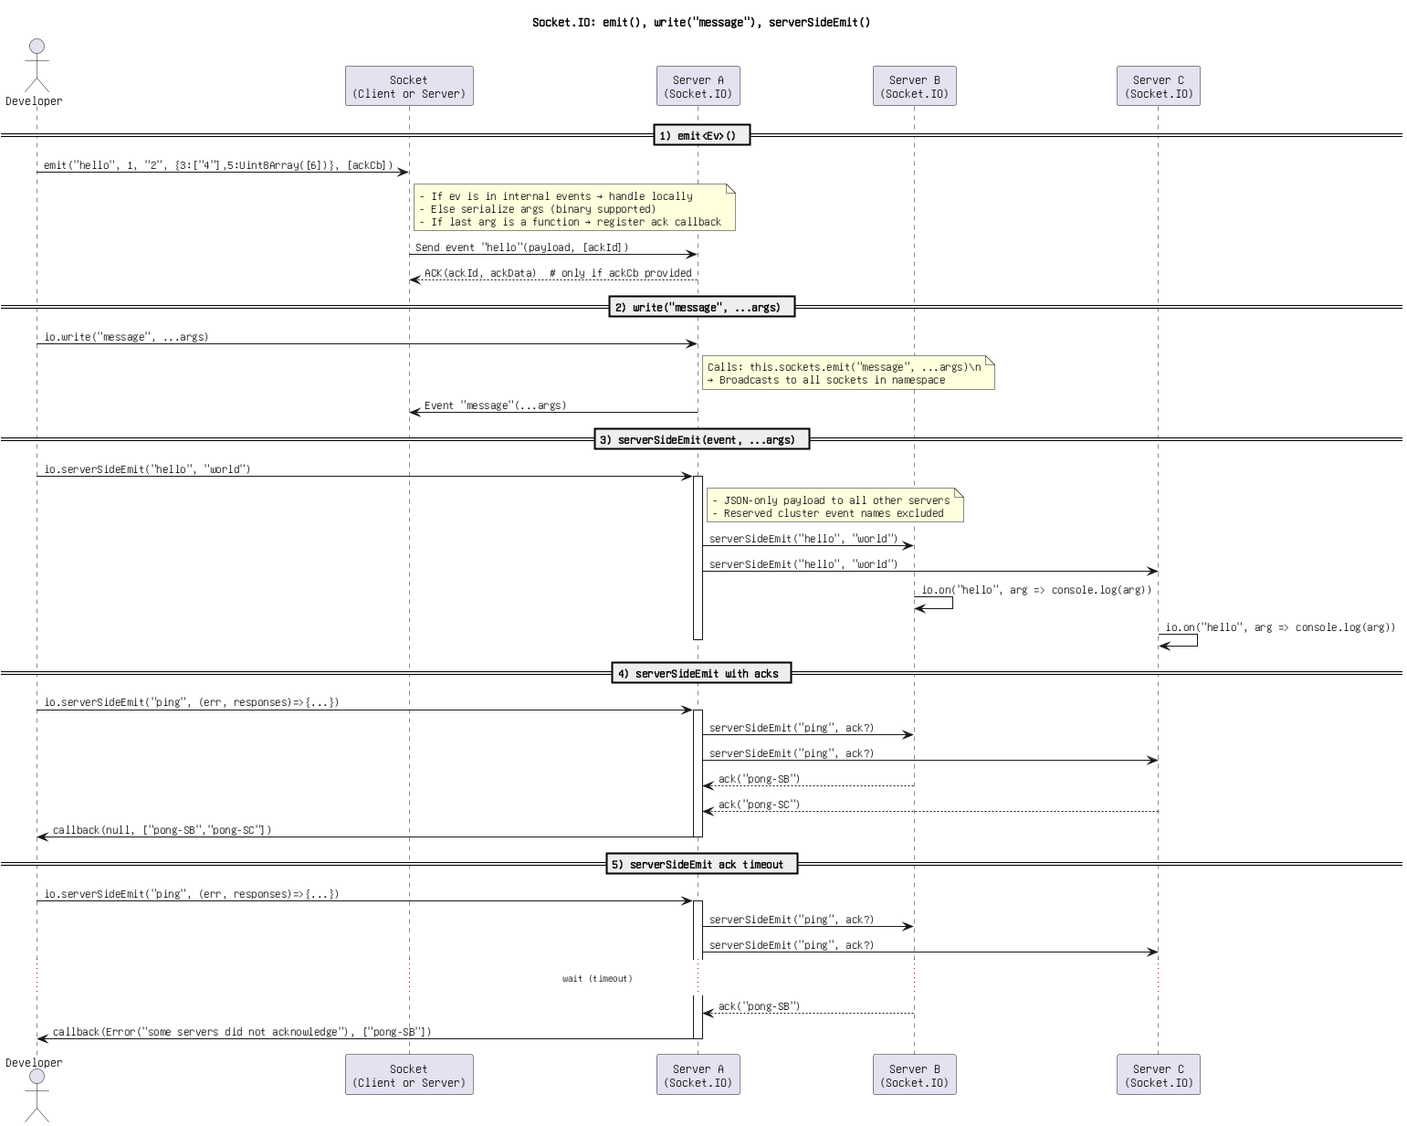

Figure 50: Socket.IO_ emit(), write(_message_), serverSideEmit().png

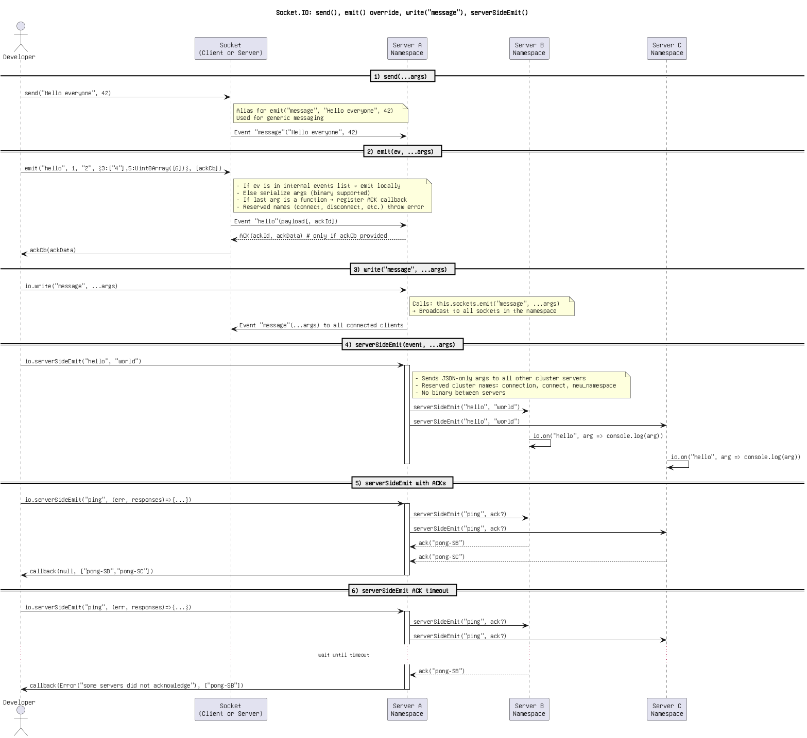

Figure 51: Socket.IO_ send(), emit() override, write(_message_), serverSideEmit().png

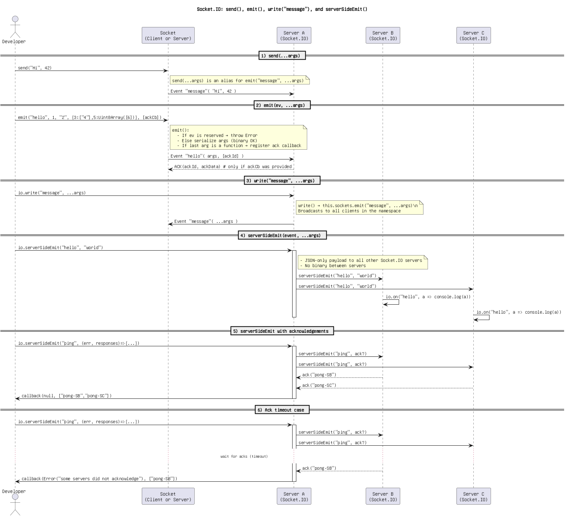

Figure 52: Socket.IO_ send(), emit(), write(_message_), and serverSideEmit().png

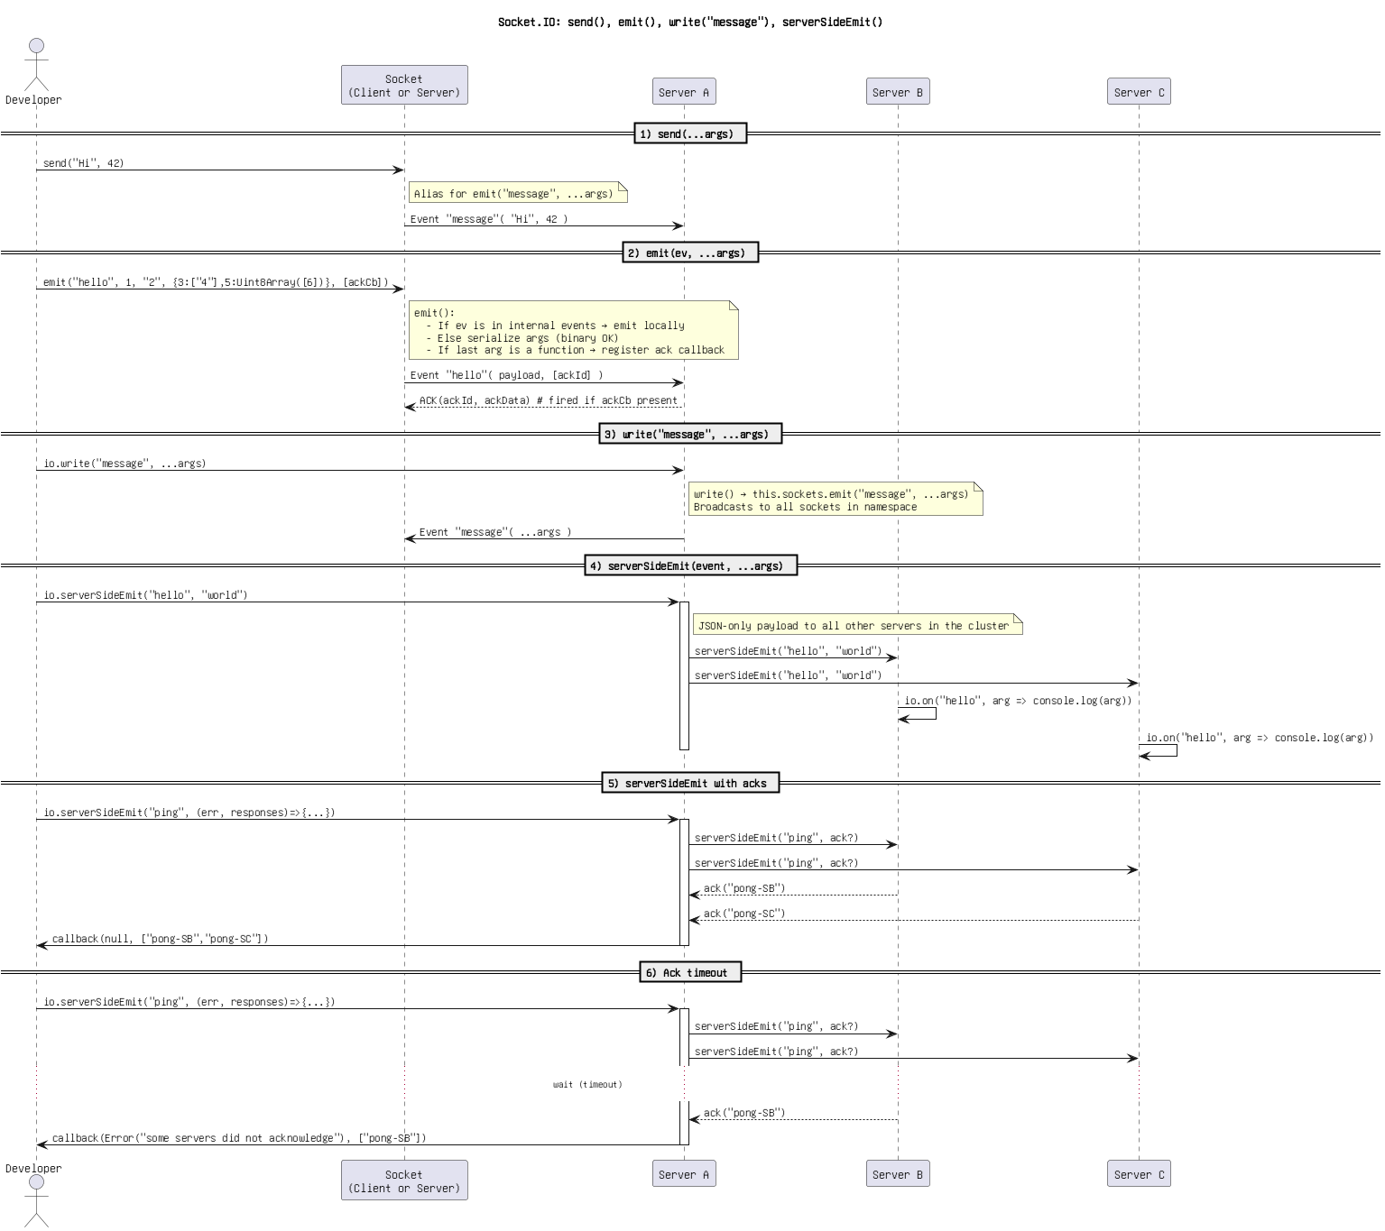

Figure 53: Socket.IO_ send(), emit(), write(_message_), serverSideEmit().png

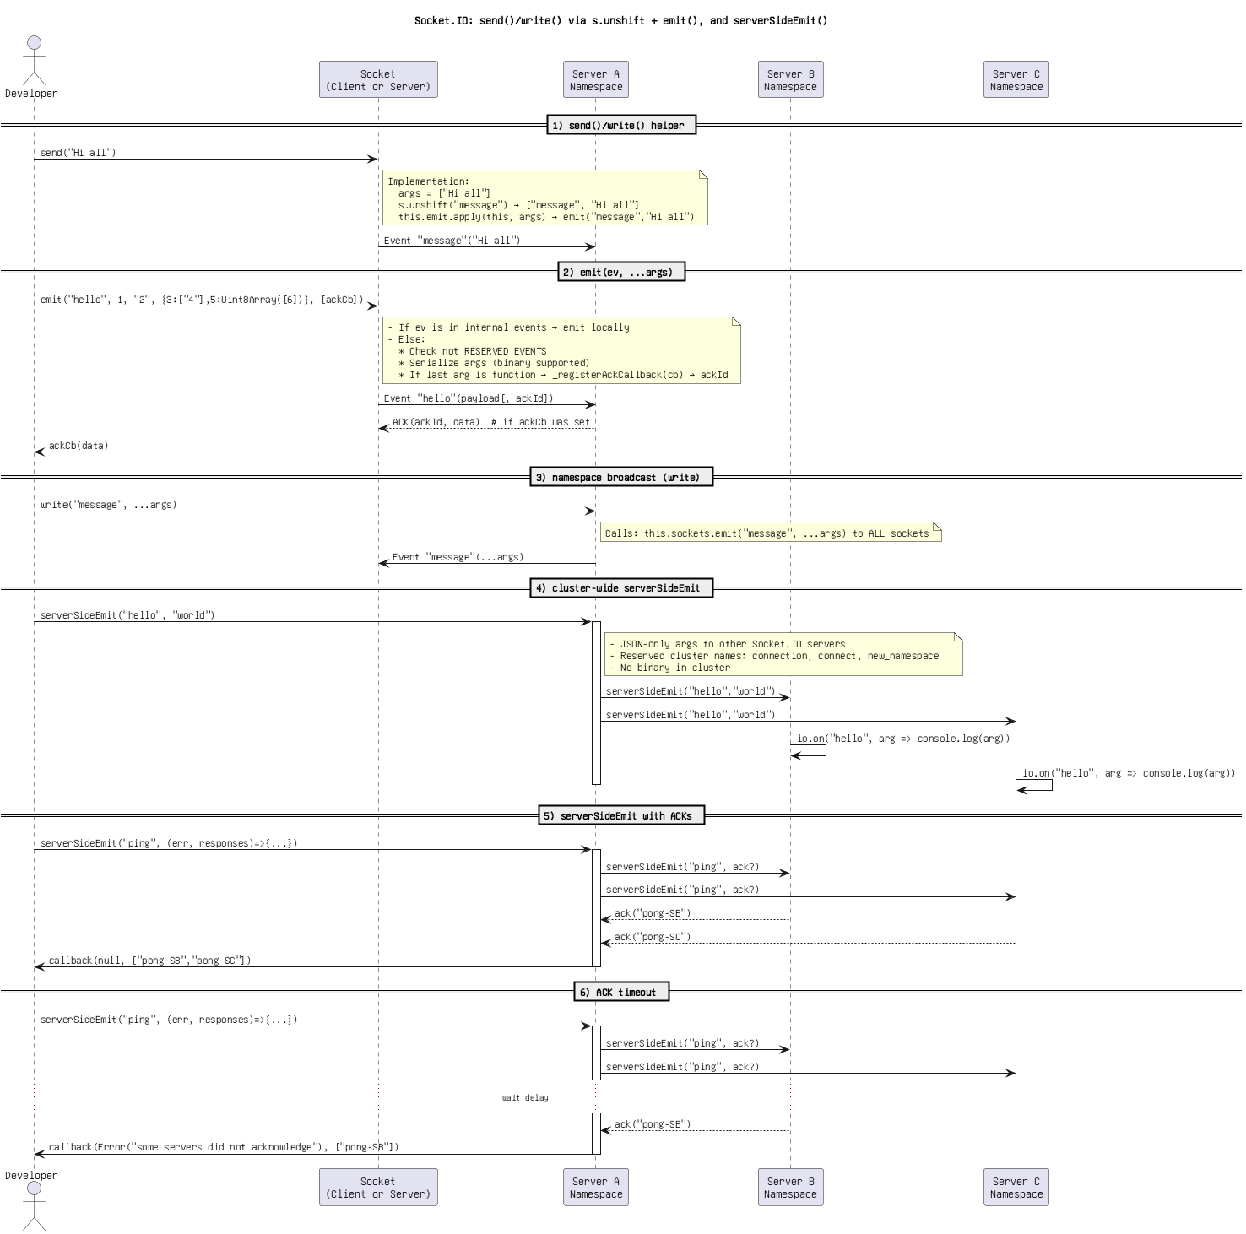

Figure 54: Socket.IO_ send()_write() via s.unshift + emit(), and serverSideEmit().png

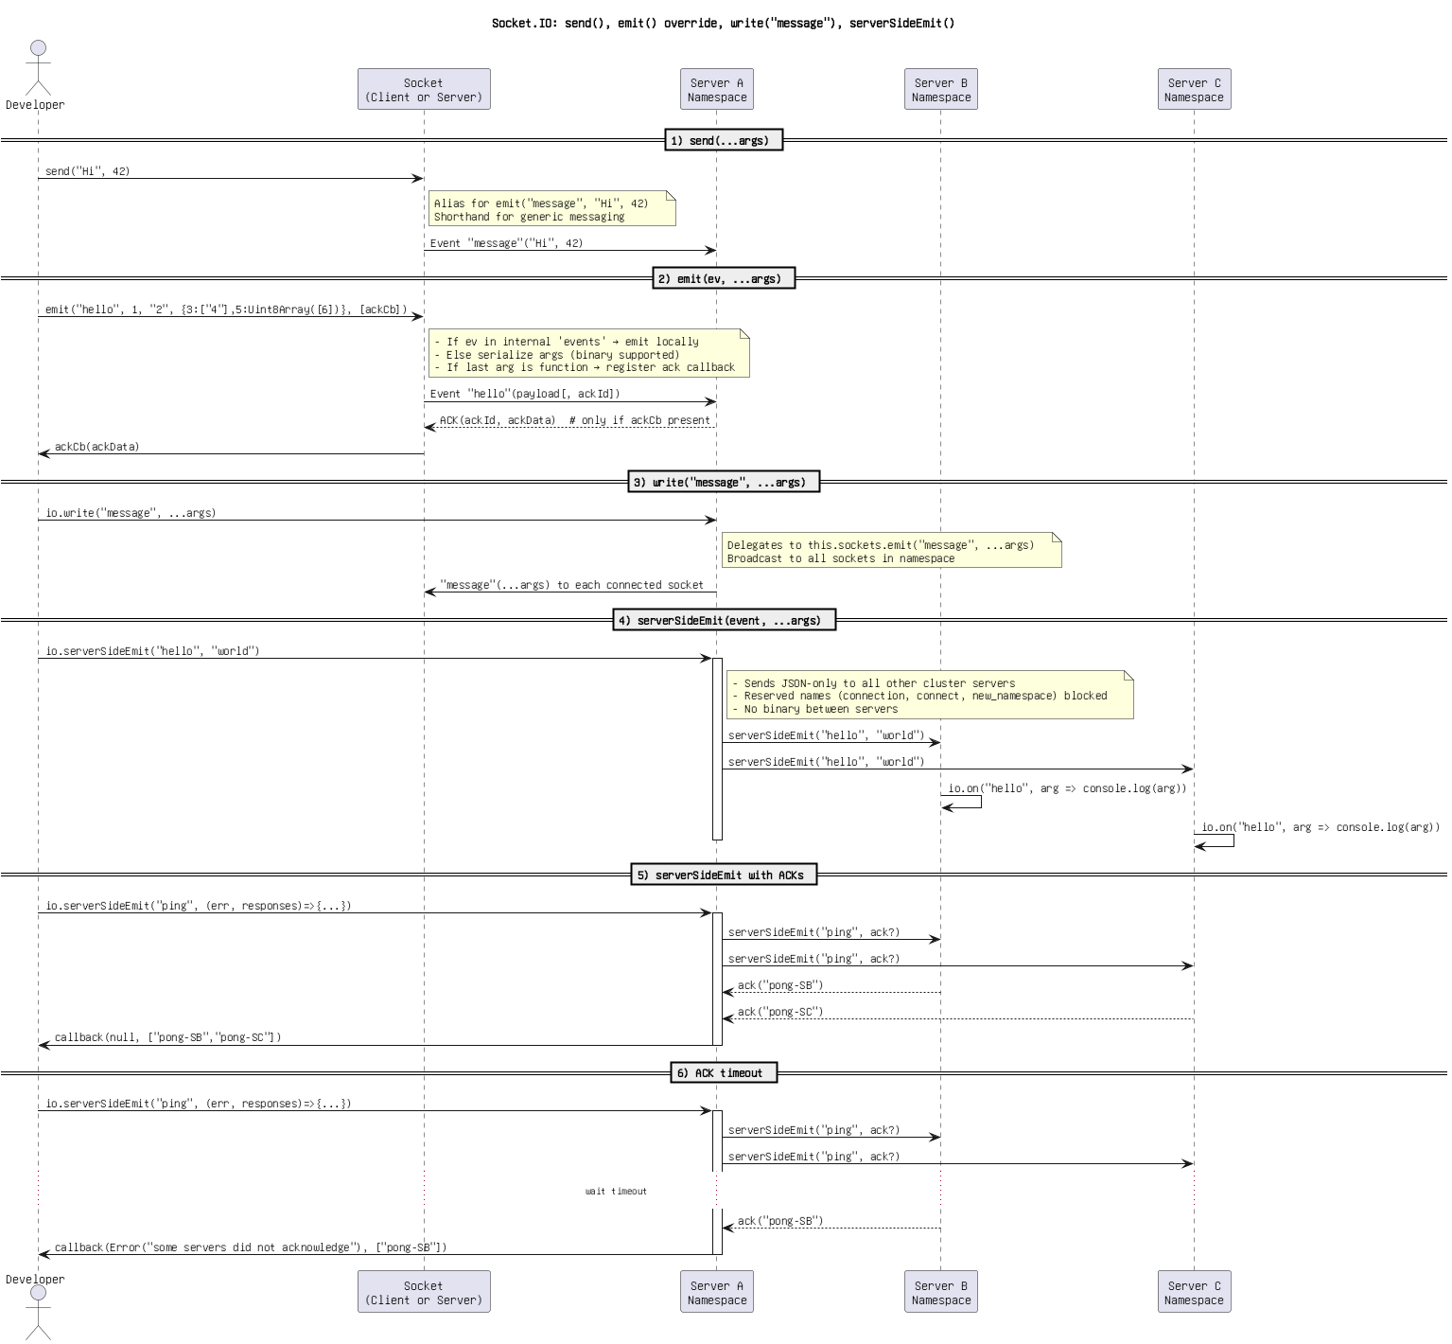

Figure 55: Untitled DiSocket.IO_ send(), emit() override, write(_message_), serverSideEmit()agram.png

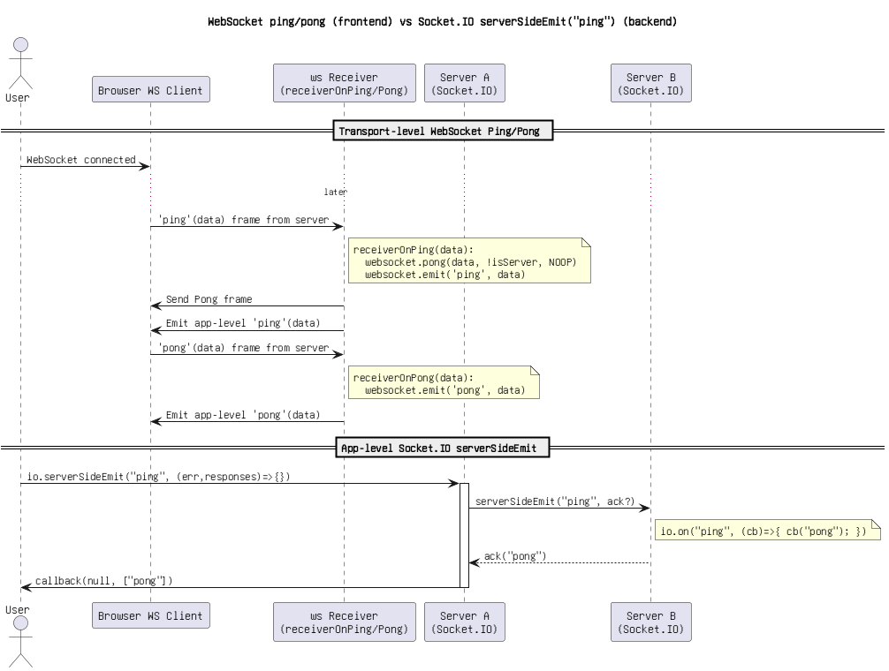

Figure 56: WebSocket ping_pong (frontend) vs Socket.IO serverSideEmit(_ping_) (backend).png

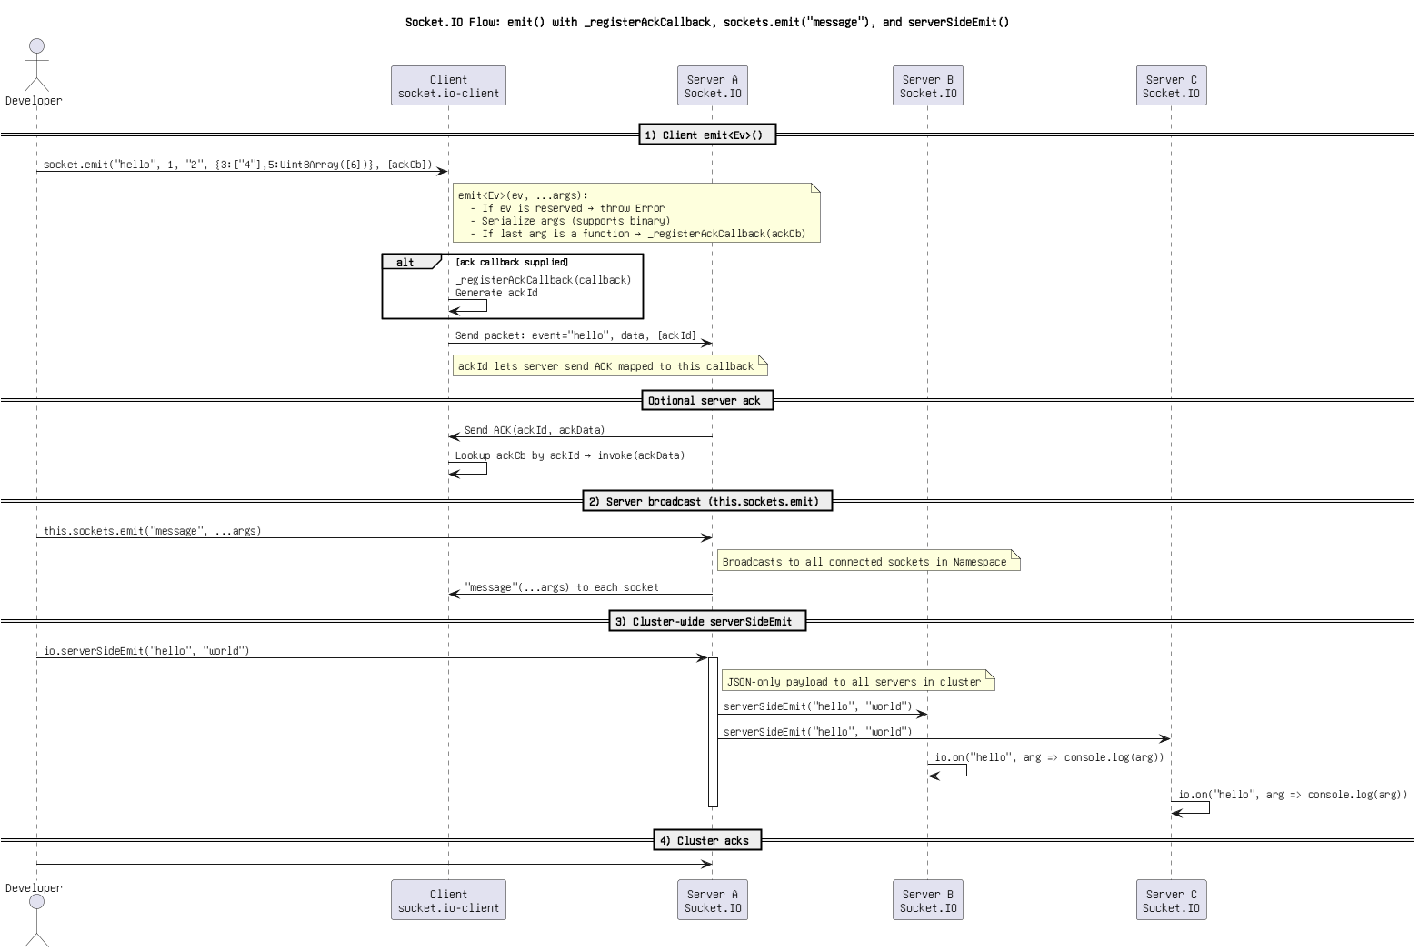

Figure 57: socket.IO Flow_ emit() with _registerAckCallback, sockets.emit(_message_), and serverSideEmit().png

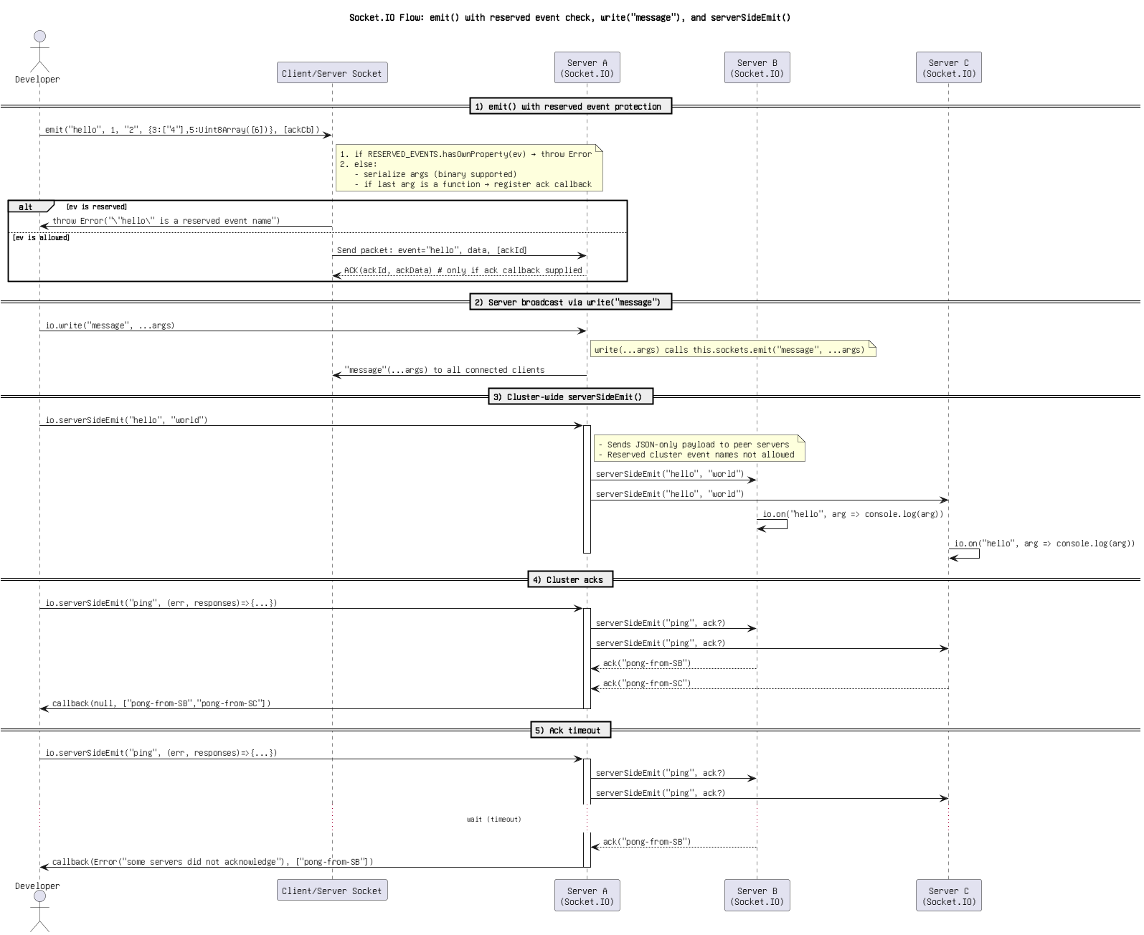

Figure 58: socket.IO Flow_ emit() with reserved event check, write(_message_), and serverSideEmit().png